





Indian Institute of Technology, Kanpur

Department of Earth Sciences

ESO213A: Fundamentals of Earth Sciences

Lecture 24. History of the Earth

**Santanu Misra**

Course Instructor

[*smisra@iitk.ac.in*](mailto:smisra@iitk.ac.in)[*http://home.iitk.ac.in/~smisra/*](http://home.iitk.ac.in/~smisra/)



**Aims of this lecture**

Methods of Studying the Past

Reconstruction of history from stratigraphic records

**Reading:**

Marshak’s Book (Part‐IV)

Grotinger & Jordan’s book (Chapter 8) [*for the entire week*]





**Earth has a History**

Geologic materials record enormous changes. Earth is a complex, evolving system.

 Physical and biological systems continuously interact.

 Earth constantly changes and has done so through time.

Species arise, flourish, and disappear forever. Continents rift, drift, and collide.

Ocean basins open and close. Sea level rises and falls.



**Earth has a History**

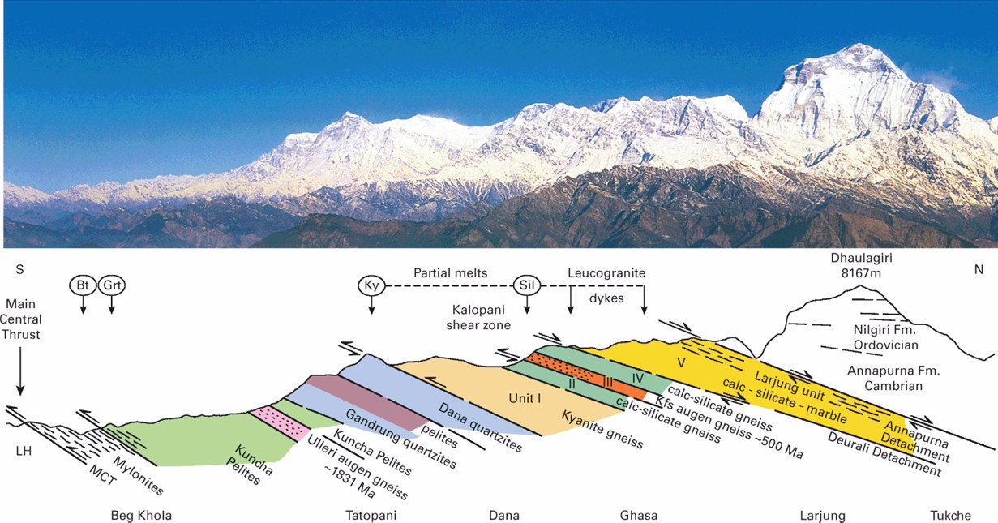

Searle, 2017





**Methods of studying the past**

Historic Earth changes are measured by…

* Orogenic events.
* Sea level.
* Climates.
* Living organisms.
* Continental positions.
* Plate boundaries.
* Chemistry.
  + Atmosphere.
  + Ocean.
* Depositional environments.

These changes are recorded in rocks.

**Challenges:**

* Discontinuous record
* Erosion
* Younger rocks are better preserved; older rocks less
* **There are still abundance of evidences**



**Ancient Orogens**

* Ancient orogens – Former mountain belts.
  + Igneous activity, deformation, and metamorphism.
  + Thick sedimentary deposits filling foreland basins.
  + Ancient orogenic belts expose deeply buried rocks.

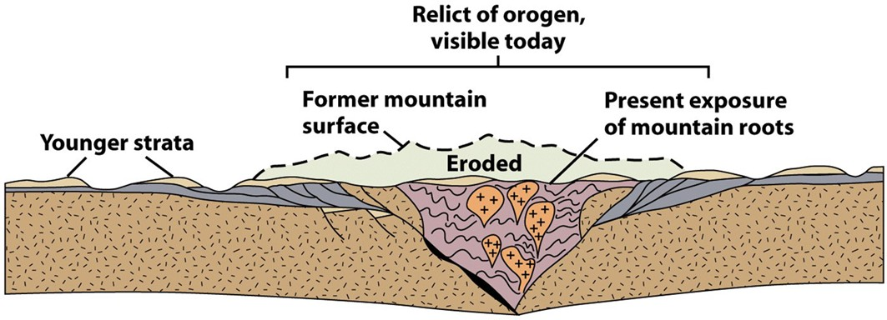

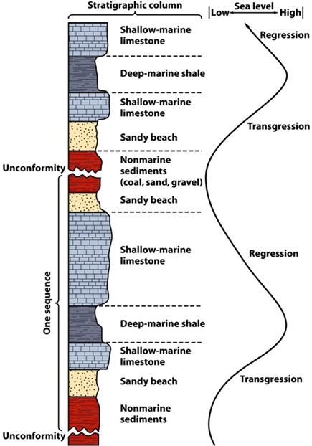



**Depositional Environments**

* Recognizing depositional environments.
  + Successions of strata record changes in depositional settings.
* Recognizing sea level changes.
  + Sediments record sea level flux.
  + Shallow and deep environments create distinctive sediments.



**Depositional Environments**

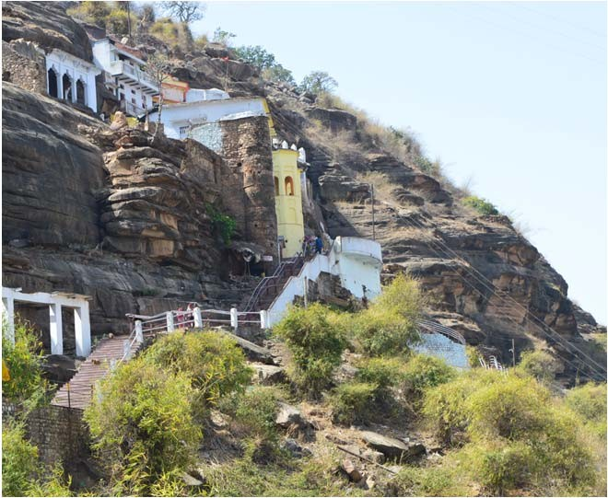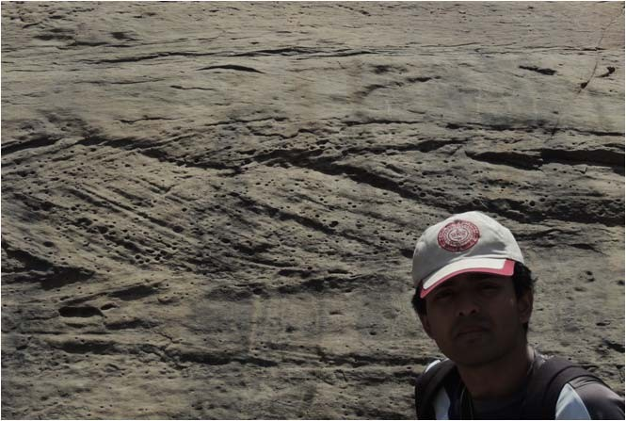

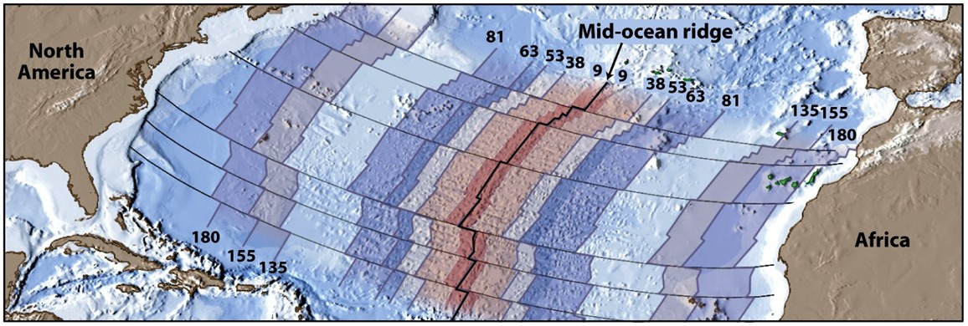



**Changing Continental Positions**

* Changing continental positions are preserved.
  + Paleomagnetism captures paleolatitude.
  + Ocean width changes by reversing sea‐floor anomalies.
  + Rock and fossil distributions compare across oceans.



**Palaeoclimate**

* Paleoclimates – Rocks preserve ancient climates.
  + Tropical – Extensive coral reefs.
  + Subtropical – Extensive deserts.
  + Polar – Extensive glacial deposits.
* Climatic belts expand and contract.
  + Greenhouse Earth.
  + Snowball Earth.
* 18O/16O isotopic ratios preserve ancient temperatures

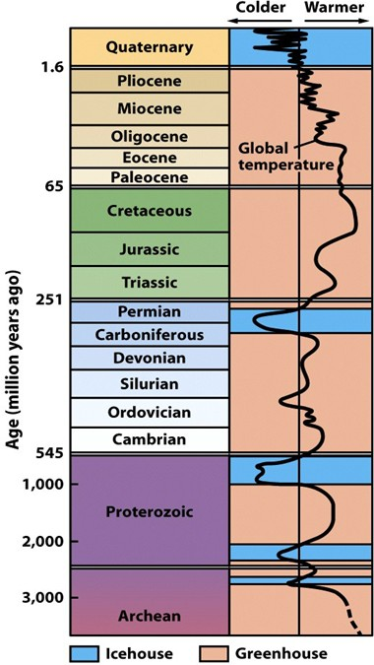

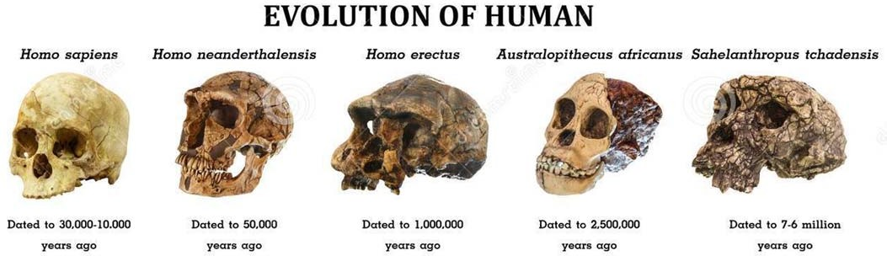



**Evolution of Life**

* Evolution – Fossils preserve changes in Earth’s life.
  + Sedimentary rocks preserve fossil ecosystems.
  + Organisms inhabiting Earth have obviously changed.
    - Over geologic time, most species have exhibited both…
      * Trends toward specialization.
      * Catastrophic extinctions.

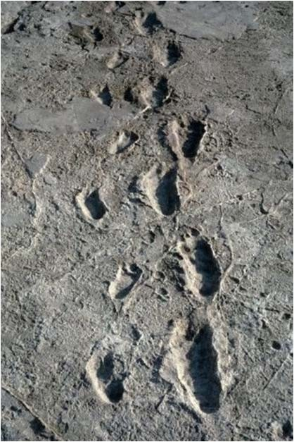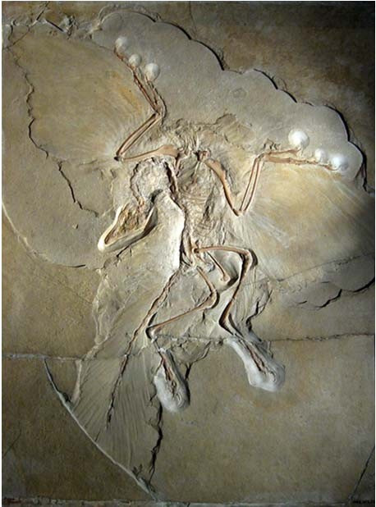

**Evolution of Life**

Archaeopteryx fossil

20,000‐Year‐Old Human Footprints





**History from Stratigraphic Records**

**Stratigraphy** is a branch of geology concerned with the study of rock layers (strata) and layering (stratification). It is primarily used in the study of sedimentary and layered volcanic rocks.

**Original horizontality:** all rock layers were originally horizontal (*Nicolaus Steno*).

**Superposition:** in a sequence of sedimentary rock layers, each layer of rock is older than the layer above it and younger than the rock layer below it (*Nicolaus Steno*).

**Faunal succession:** fossils occur in a definite, invariable sequence in the geologic record (*William Smith*).

**Cross‐cutting relationship:** if a fault or other body of rock cuts through another body of rock then it must be younger in age than the rock through which it cuts and displaces (*James Hutton*).

**Laws of inclusions:** if a rock body contained fragments of another rock body, it must be younger than the fragments of rock it contained. The intruding rock must have been there first to provide the fragments. (*James Hutton*).

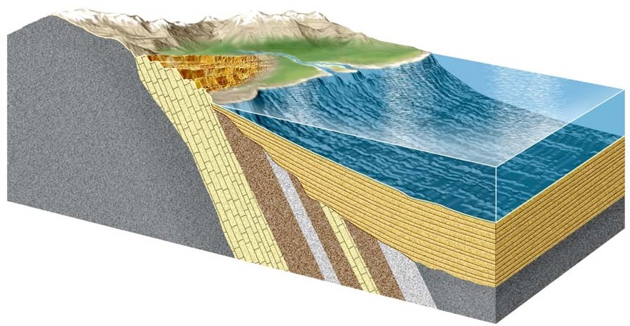

**Original Horizontality and Superposition**

Younger

Older

Sediments are deposited in horizontal

layers and slowly change into rock.

sedimentation in

lake or sea

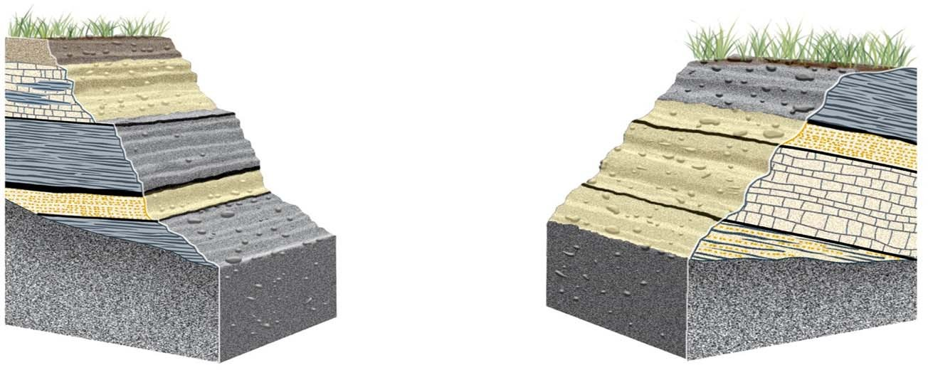

**Faunal Succession**

**Outcrop A**

**Outcrop B**

**I**

**II**

**II**

**III**

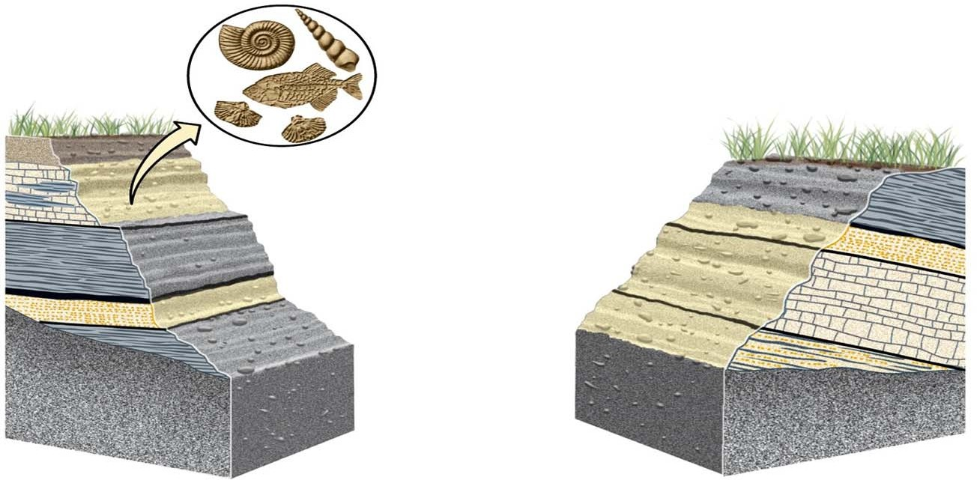

**Faunal Succession**

**Outcrop A**

**Outcrop B**

**I**

**II**

**II**

**III**

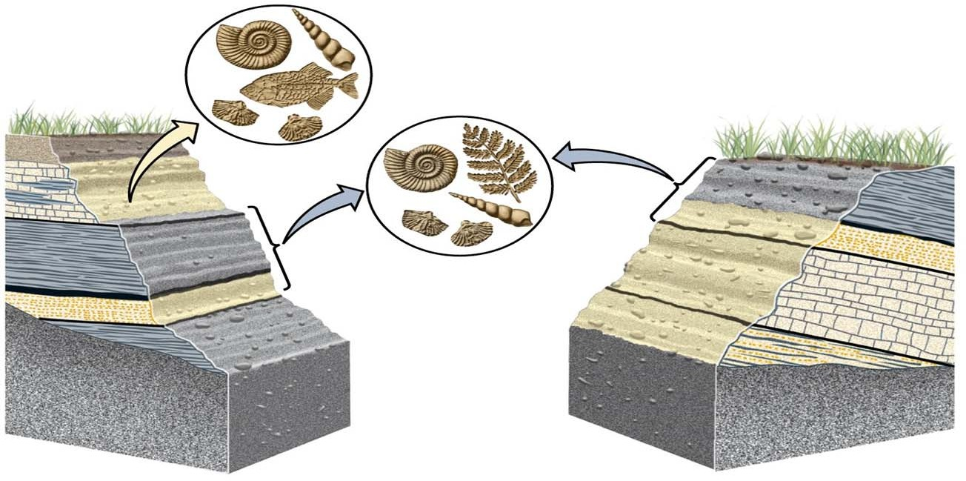

**Faunal Succession**

**Outcrop A**

**Outcrop B**

**I**

**II**

**II**

**III**



**Faunal Succession**

**Outcrop A**

Some of the fossils found in

outcrop A are the same as fossils found in outcrop B, some distance away.

**Outcrop B**

**I**

**II**

**II**

**III**



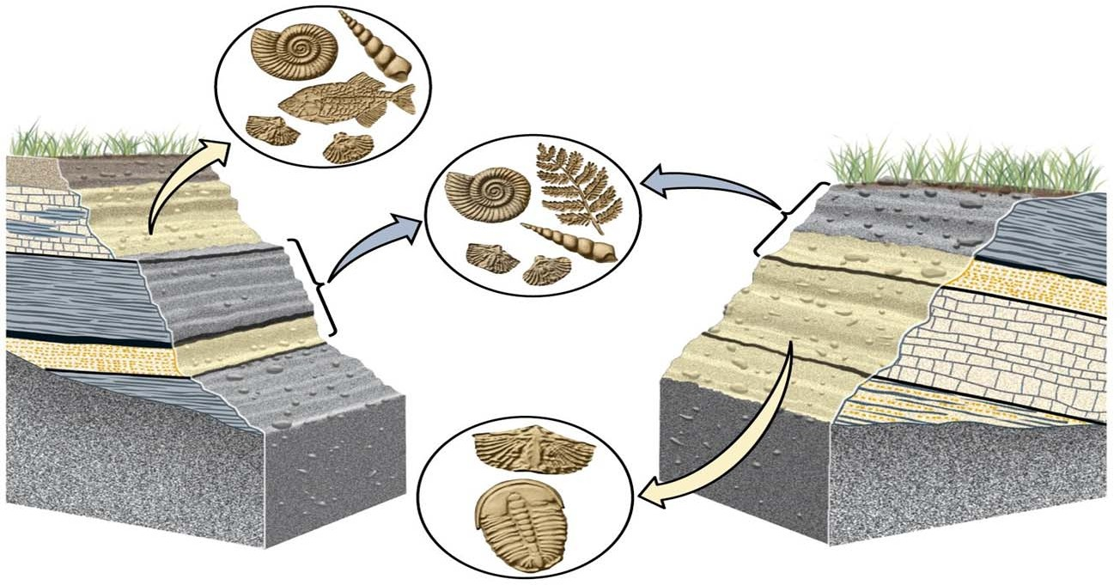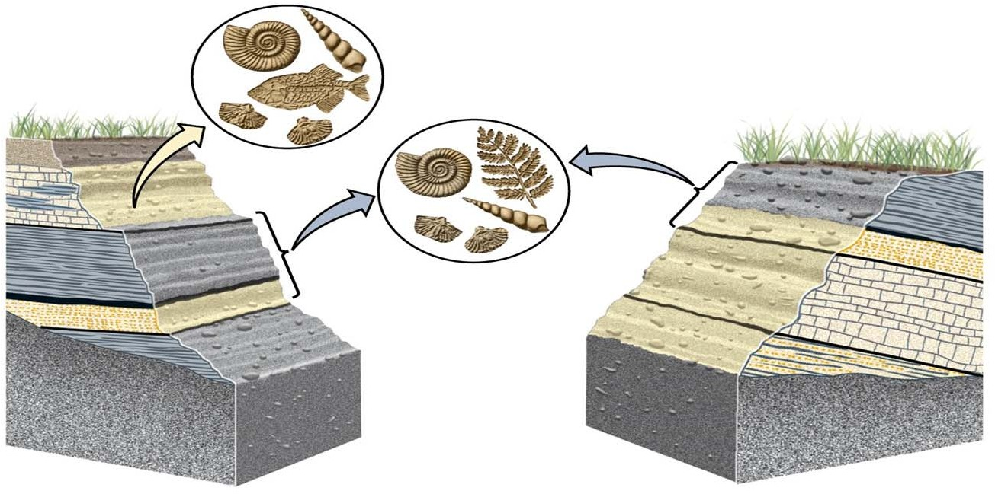

**Faunal Succession**

**Outcrop A**

Some of the fossils found in

outcrop A are the same as fossils found in outcrop B, some distance away.

**Outcrop B**

**I**

**II**

**II**

**Layers with the same fossils are**

**the same age.**

**III**

**Faunal Succession**

**Outcrop A**

Some of the fossils found in

outcrop A are the same as fossils found in outcrop B, some distance away.

**Outcrop B**

**I**

**II**

**II**

**Layers with the same fossils are**

**the same age.**

**III**

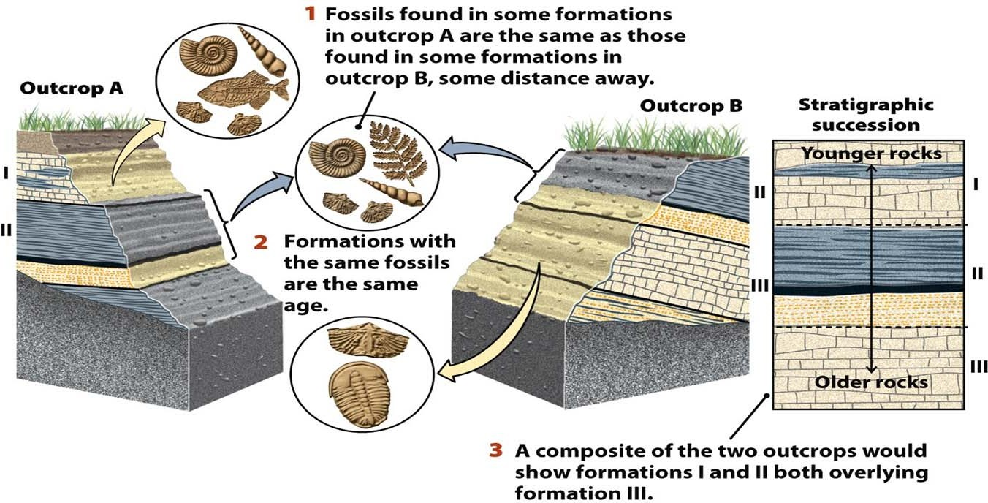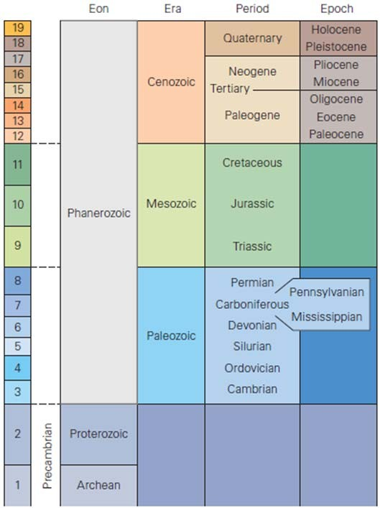

**Faunal Succession**



**Faunal & Stratigraphic Succession**

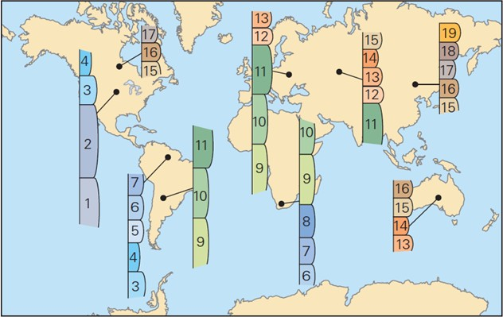

By correlation, the strata from localities around the world can be stacked in a chart representing geologic time to create the geologic column. Geologists assigned names to time intervals, but since the column was built without knowledge of numerical ages, it does not depict the duration of these intervals.

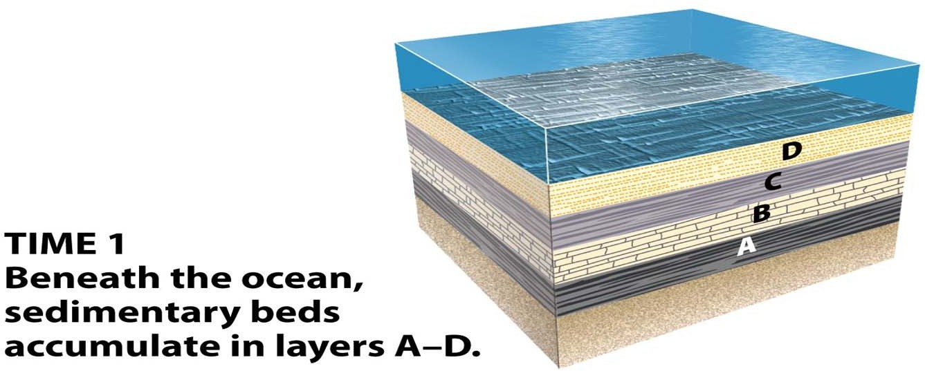



**Stratigraphic Records**

* Unconformities – gaps in the record

**Disconformity:** an unconformity between parallel layers of sedimentary rocks which represents a period of erosion or non‐deposition. Disconformities are marked by features of subaerial erosion. This type of erosion can leave channels and paleosols in the rock record

**Nonconformity**: A nonconformity exists between sedimentary rocks and metamorphic or igneous rocks when the sedimentary rock lies above and was deposited on the pre‐existing and eroded metamorphic or igneous rock.

**Angular Unconformity:** an unconformity where horizontally parallel strata of sedimentary rock are deposited on tilted and eroded layers, producing an angular discordance with the overlying horizontal layers.

**Paraconformity:** a type of unconformity in which strata are parallel; there is no apparent erosion and the unconformity surface resembles a simple bedding plane. It is also called nondepositional unconformity or pseudoconformity. A paraconformity of shorter time period is known as Diastem.



**Disconformity**

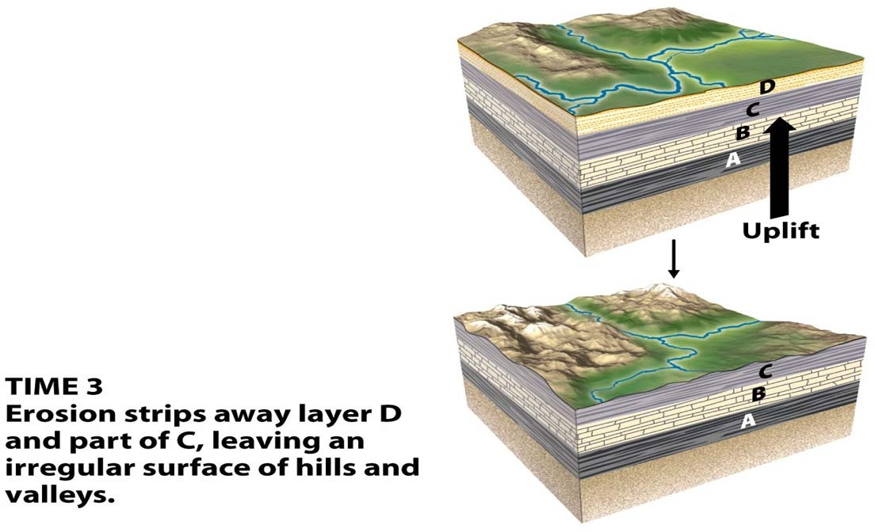

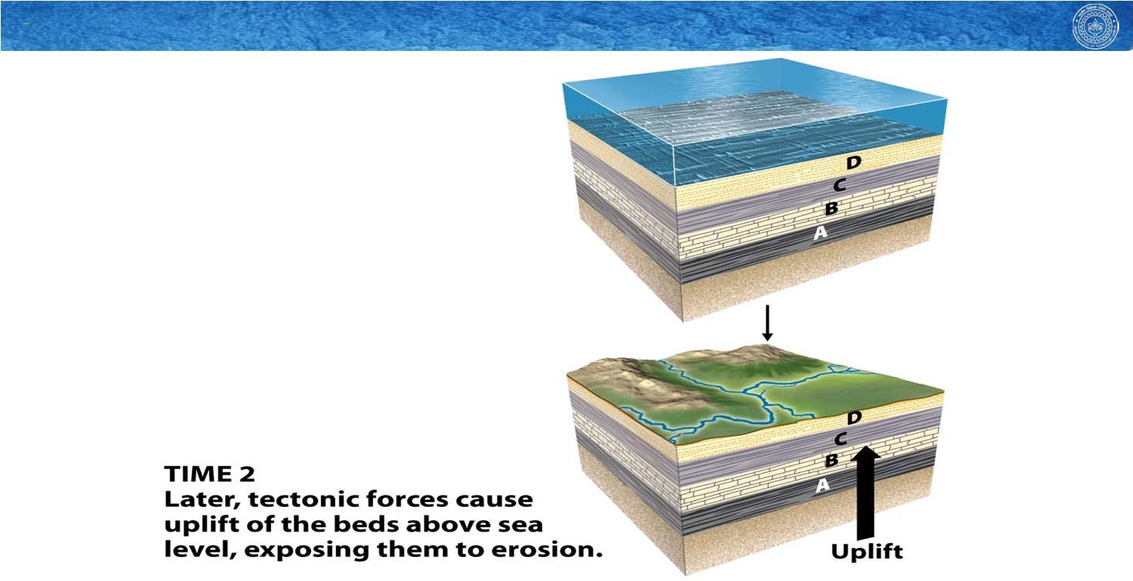

**Disconformity**



**Disconformity**

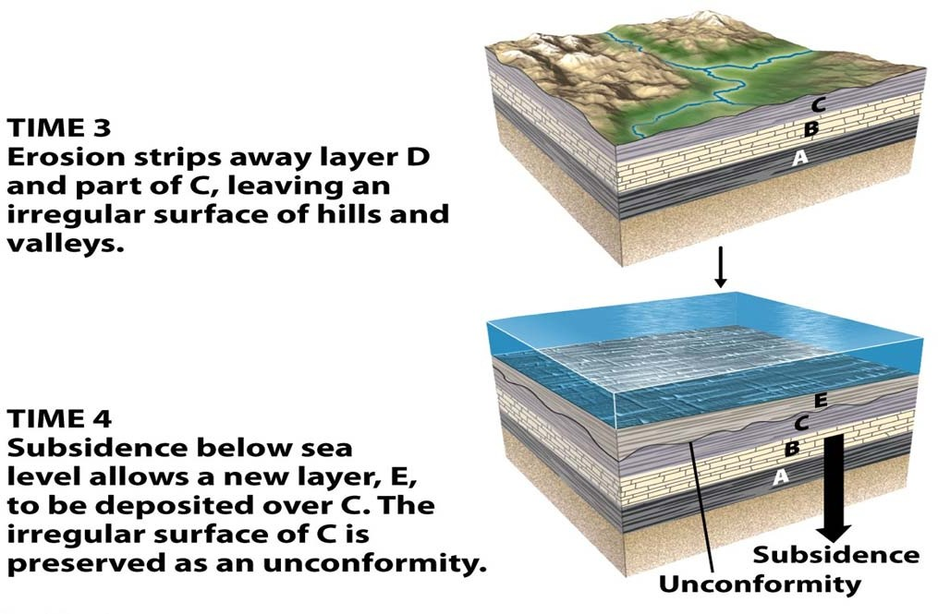



**Disconformity**

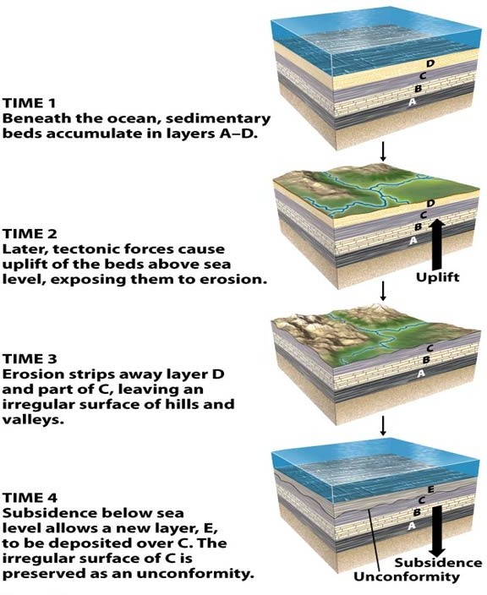

**Disconformity**

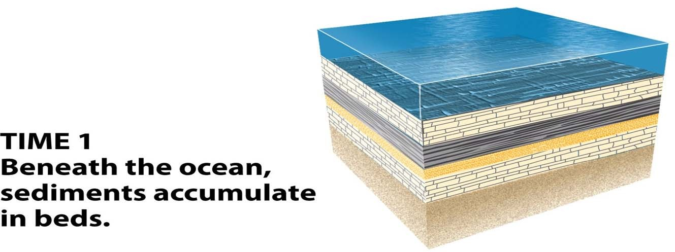



**Angular Unconformity**

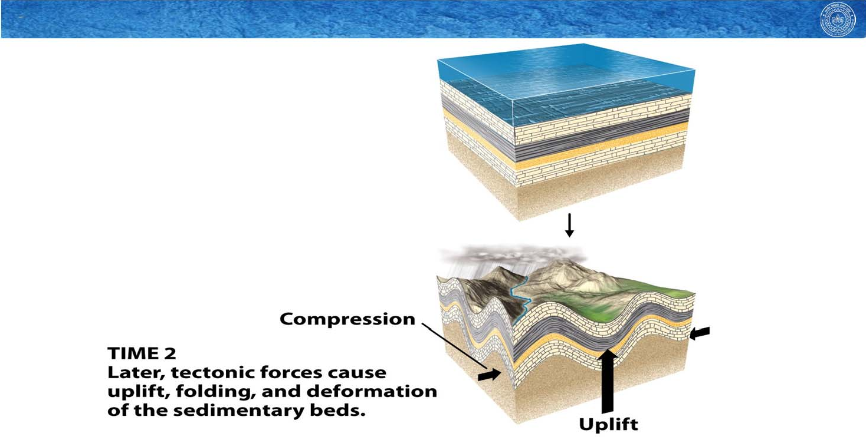

**Angular Unconformity**

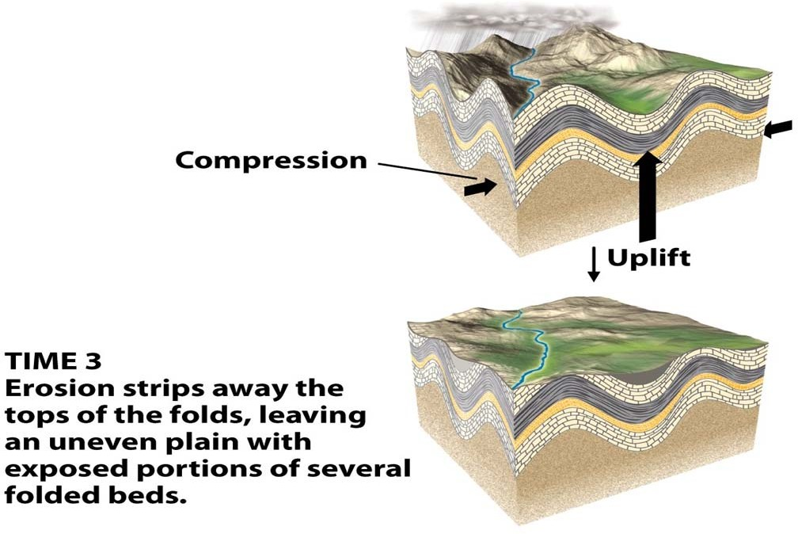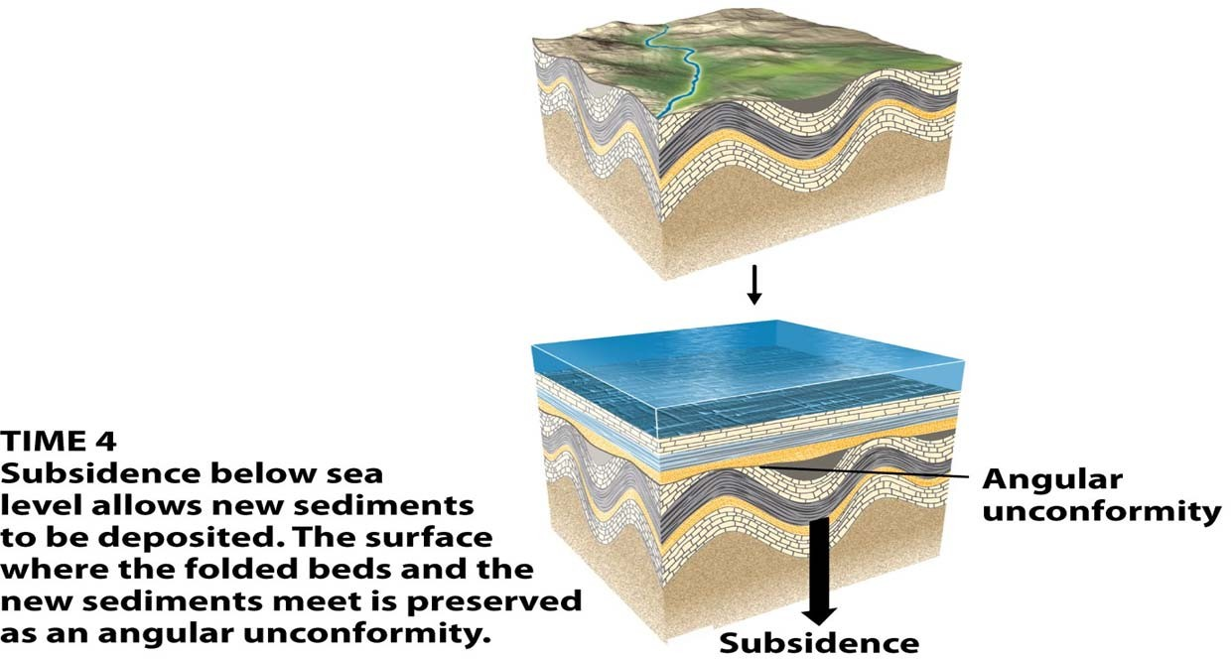



**Angular Unconformity**



**Angular Unconformity**

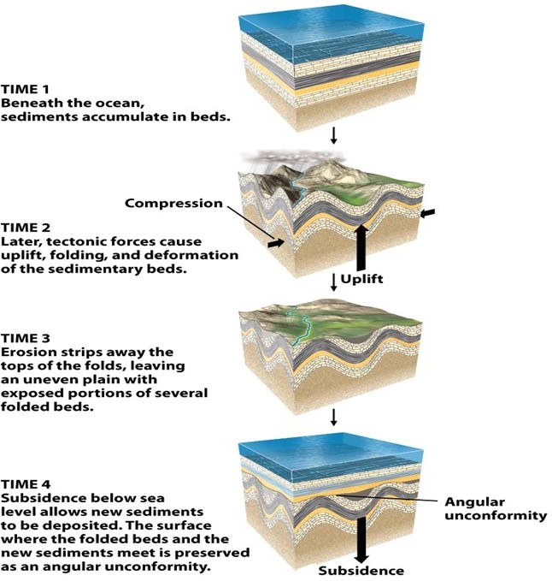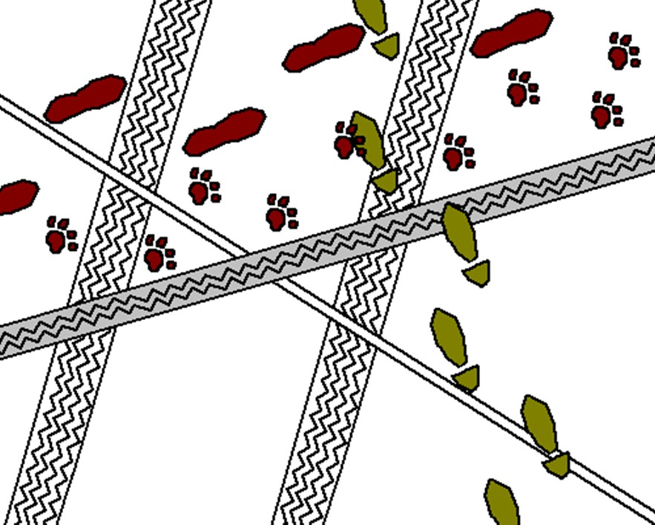

**Angular Unconformity**



**Cross‐Cutting Relationship**

**walker with dog walker motorbike bicycle**

**car**

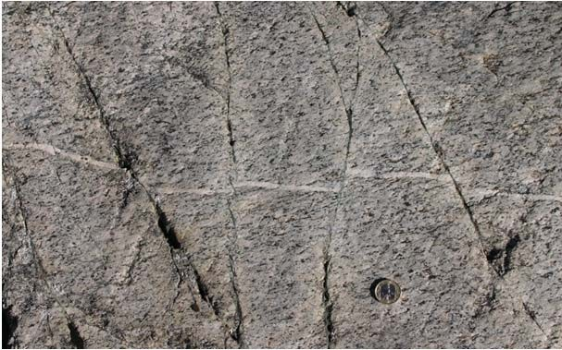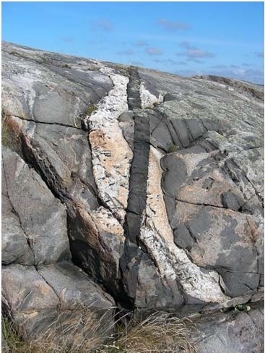



**Cross‐Cutting Relationship**

The latest fracture movement should displace previous ones in a terrain with multiple generation of fractures.

If the latest fracture involve shear component (Type ‐II), the previous fractures should slip accordingly along latest fracture.



**Cross‐Cutting Relationship**

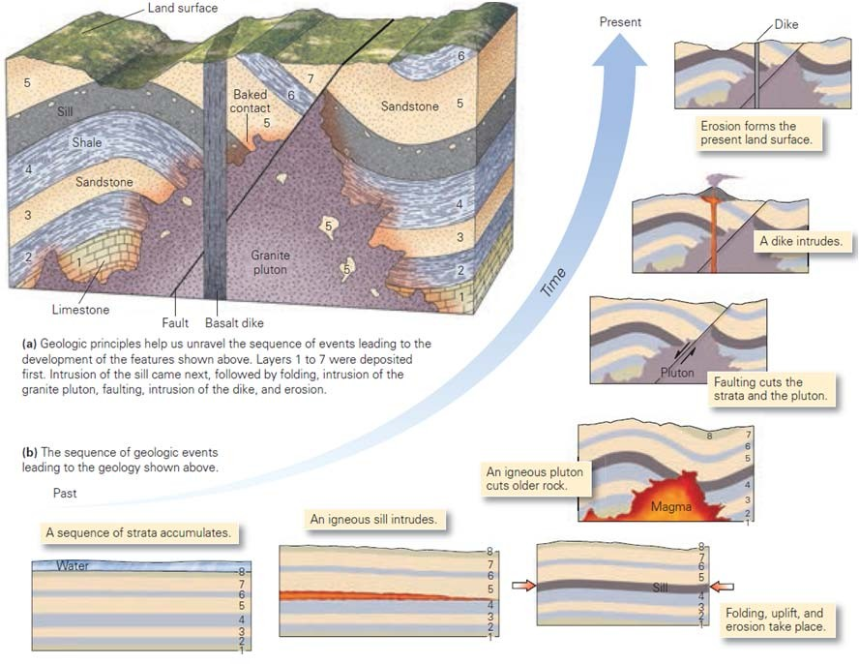





**Next Lecture**

Geological Time Scale (relative and absolute)







Indian Institute of Technology, Kanpur

Department of Earth Sciences

ESO213A: Fundamentals of Earth Sciences

Lecture 25. Geological Time Scale

**Santanu Misra**

Department of Earth Sciences

Indian Institute of Technology, Kanpur

[*smisra@iitk.ac.in*](mailto:smisra@iitk.ac.in)[*http://home.iitk.ac.in/~smisra/*](http://home.iitk.ac.in/~smisra/)



**Aims of this lecture**

Geological Time Scale: relative and absolute (numerical) ages Biography of the Earth

**Reading:**

Marshak’s Book (Part‐IV)

Grotinger & Jordan’s book (Chapter 8) [*for the entire week*]





**Relative and absolute (numerical) ages**

 Geologists studied the principles stratigraphic successions (previous lecture) and the Theory of Uniformitarianism (*physical processes we observe operating today also operated in the past, at roughly comparable rates* OR *present is the key to the past*) to determine the ***relative ages*** of the rocks structures, and other geologic features at a given location (Geologic Events).

 The relative ages cannot suggest time‐line in the Earth history. of the rocks structures, and other geologic features at a given location (Geologic Events). This situation changed with the discovery of radioactivity. The overall determination and interpretation of numerical ages as **geochronology**. The technique of isotopic dating has been vastly improved over the years and we can now know more or less precisely the time‐lines of the past geological events (***the Numerical Age***).



**Relative timeline of IIT Kanpur**

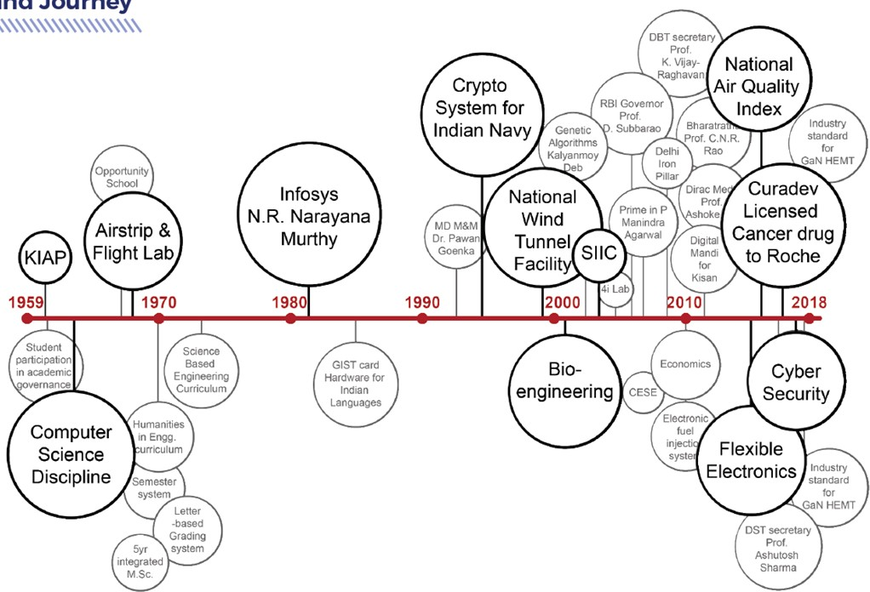





**Absolute (numerical) timeline of IIT Kanpur**



**Relative Geological Time Scale**

By correlating strata from locality to locality at millions of places around the world, geologists have pieced together a composite stratigraphic column, called the **geologic column**, that represents the entirety of Earth history.

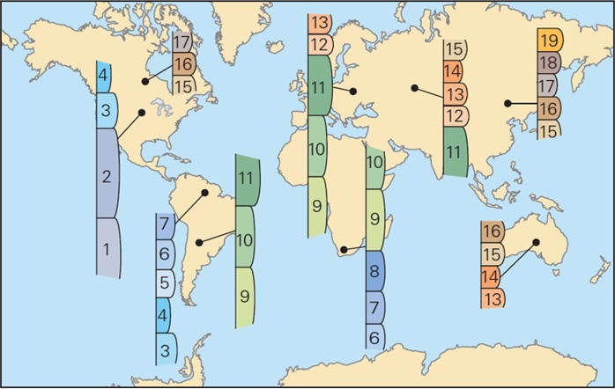





**Relative Geological Time Scale**

**EONS**: The largest subdivisions break Earth’s history into the *Hadean, Archean, Proterozoic*, and Phanerozoic—the first three of these, together, constitute the **Precambrian**.

* there is no rock record from Hadean
* *zoic* means LIFE, Proterozoic → first life; Phanerozoic → visible life
* because decades after the EONS had been named, geologists discovered that the earliest life, cells of bacteria and archaea, actually appeared during the Archean Eon.

**ERAS**: Eons are subdivided into **eras**. The Phanerozoic Eon, for example includes, in order from oldest to youngest, the Paleozoic (*ancient life*), Mesozoic (*middle life*), and Cenozoic (*recent life*) Eras.

Eras are further subdivided to **PERIODS** and each periods into **EPOCHS**.

‐ The names of the Periods are mostly from places where the signature rocks are best exposed

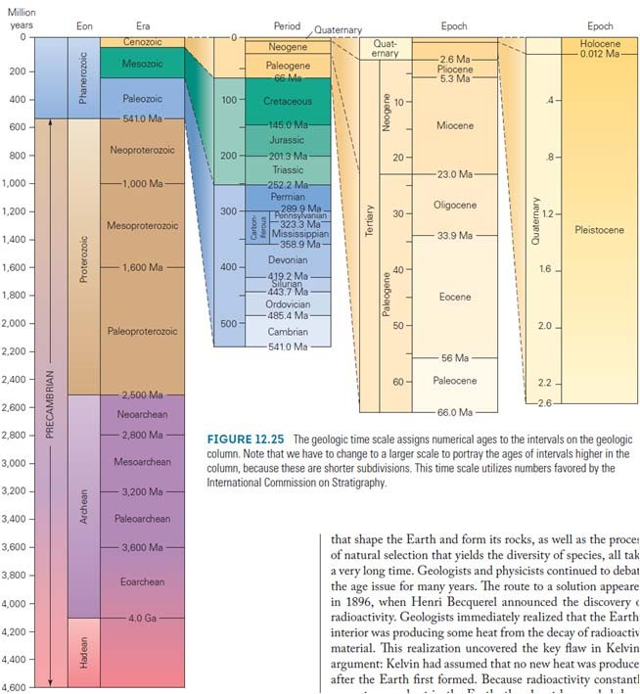

**Absolute (Numerical) Geological Time Scale**

The geologic time scale assigns numerical ages to the intervals on the geologic column. Note that we have to change to a larger scale to portray the ages of intervals higher in the column, because these are shorter subdivisions. This time scale utilizes numbers favored by the International Commission on Stratigraphy.







**Biography of the Earth**



**The Hadean Eon**

* The time between 4.57 and 3.8 Ga is the Hadean Eon.
  + Named for Hades, the Greek god of the underworld.
  + Began with formation of Earth by planetesimal accretion.
* Earth was heated by impacts and radioactive decay.
* Earth was hot enough to partially melt by ~ 4.5 Ga.
  + The molten Earth underwent chemical differentiation.
    - Gravity pulled molten iron into the center.
    - The ultramafic mantle remained as a thick shell.

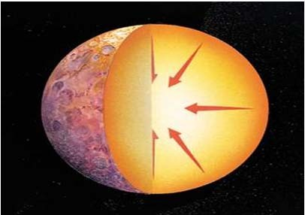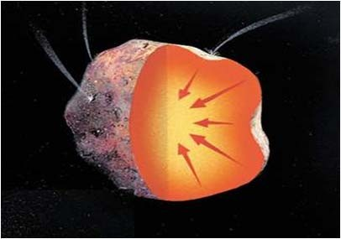

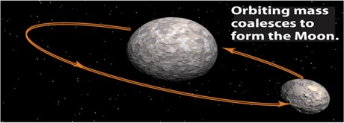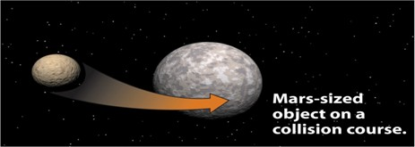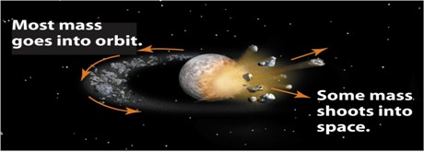



**The Hadean Eon**

* After differentiation, Earth smashed a protoplanet.
* The size of Mars, this planet blasted…
  + A sizeable chunk of Earth’s mantle.
  + Much of the protoplanet’s mantle.
* Debris from the collision formed a ring around Earth.
* This debris coalesced to form the moon.
* When 1st formed, moon was much closer (20,000 km).
* Today it is 19x farther away (384,000 km).



**The Hadean Eon**

* Earth was inhospitable; a molten surface.
  + Evidence of solidified igneous rock dates from 4.4 Ga.
    - This evidence is from zircon grains, not a whole rock.
* Volcanic outgassing created a deadly atmosphere.
* N2, NH3, CH4, H2O, CO, CO2, and SO4 were components.

2‐

* This atmosphere had a greater density that today’s.
* Early formed crust was bombarded by meteorites.
  + Meteorite impacts were abundant between 4.0 and 3.9 Ga.
    - This would have destroyed early formed crust.
    - Oldest evidence of crust is 4.03 Ga.
* The first oceans formed as rain from the skies.
  + Liquid water required cooling of the surface.
  + First evidence of oceans from marine sediments ~ 3.85 Ga.

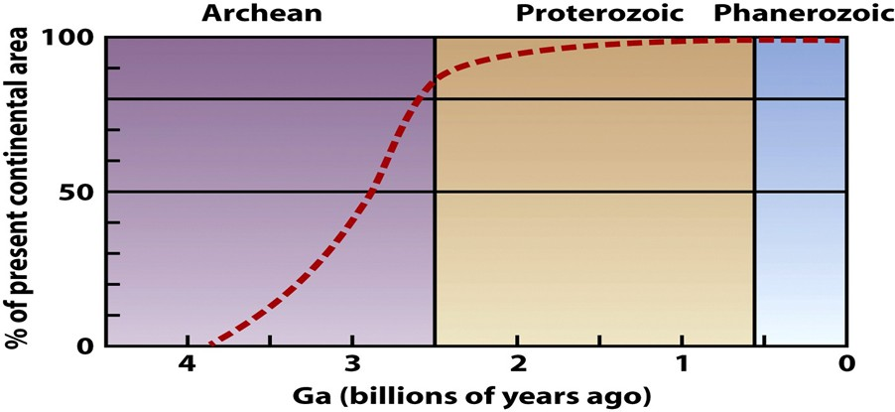



**The Archean Eon**

* Time of significant change to planet Earth.
* ~3.8 Ga, Earth had cooled to form lithosphere.
  + Intense meteorite bombardment ceased.
  + Portions of the rock record begin to survive.
* Had plate tectonics started yet? Two models:
  + Many small microplates, island arcs, and hot spot volcanoes rapidly formed and subducted crust.
  + Archean lithosphere was too hot to subduct; hot spot plume volcanics dominated formation of crust.



**The Archean Eon**

* Volume of continental crust increased dramatically.
  + 85% of modern continental area present by end of Archean.
  + Signals full development of plate tectonic processes.

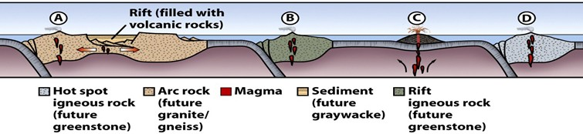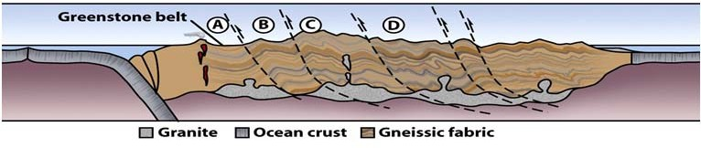



**The Archean Eon**

* How did continental crust form?
  + Low‐density felsic rocks formed above subduction zones.
    - Felsic crustal blocks grew via continental collision.
    - Felsic sediments accumulated near continental crust.
  + Mantle hot spots built mafic volcanoes.
  + Continental crust is too buoyant to subduct.
    - Jams subduction trenches.
    - Shuts off subduction.
    - Creates thickened, uplifted continental crust.
  + Frequent collisions sutured volcanic arcs, hot spots, and sedimentary debris together as protocontinents.



**The Archean Eon**

* Archean cratons consist of 5 principal rock types.
  + Gneiss – Hi‐grade metamorphics from Archean collisions.
  + Greenstone – Metamorphosed fragments of mafic rocks.
  + Granite – Magmas from partial melting of the crust.
  + Graywacke – Sedimentary debris derived from arcs.
  + Chert – Silica precipitated in the deep sea.
* Archean shallow sediments are poorly known.
  + There were few shallow depositional settings, or…
  + Few examples have survived destruction by erosion.
* Sedimentary processes were clearly operating.
  + Transport rounded sediment grains.

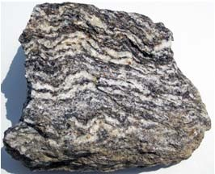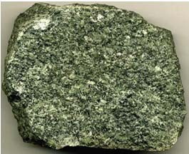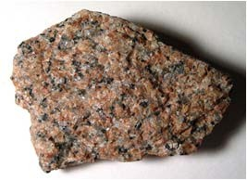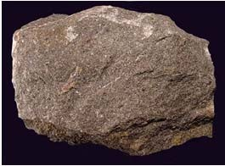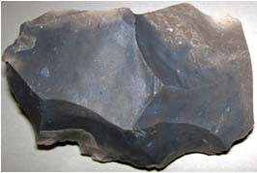

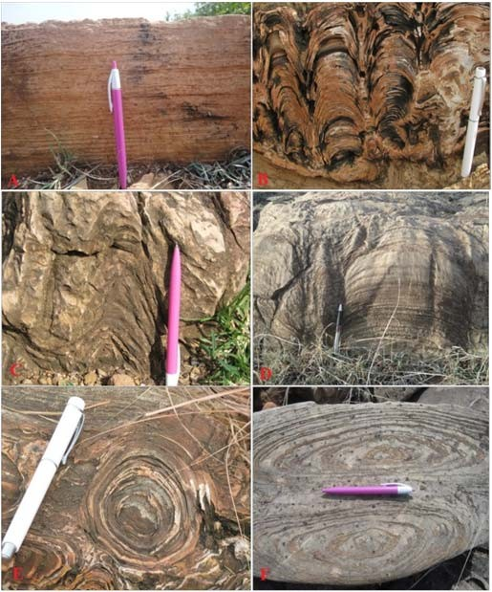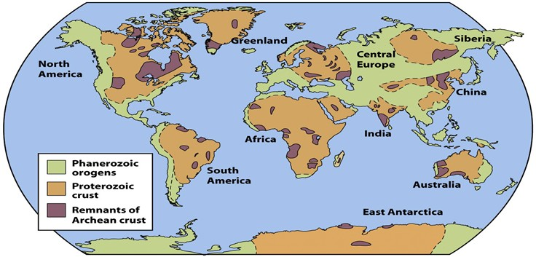



**The Archean Eon**

* Life first appeared during the Archean. Evidence?
  + Biomarker molecules; Isotopic signatures; Fossil cells.
* Clear evidence of life in rocks dated to 3.5 Ga.
  + Life may have started earlier.
* Oldest undisputed bacteria fossils ~ 3.2 Ga.
* Rocks after 3.2 Ga contain stromatolites.
  + Layered mats of cyanobacteria (blue‐green algae).
  + Sediments stuck to mucous coatings on algal filaments.
* Photosynthesis changed Earth’s atmosphere.
  + Converted CO2 and H2O to organic matter and free oxygen.

Khelen et al., 2017



**The Proterozoic Eon**

* Protero = first; zoic = life.
  + Named before Archean life was discovered.
* ~ 2 Ga (2.5 to 0.542 Ga); almost ½ of Earth history.
* The unfamiliar Archean world changed to…
  + Fewer, larger lithospheric plates.
  + Larger continental landmasses.
  + An oxygenated atmosphere.
* New continental crust formed, but at slower rates.
  + 90% of Earth’s continental crust by the middle Proterozoic.
  + Continents grew by addition of volcanic arcs.
  + Continents cooled and strengthened to become cratons.

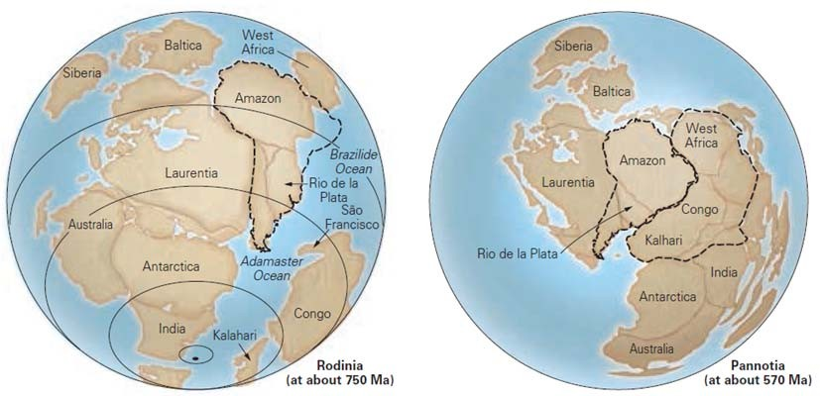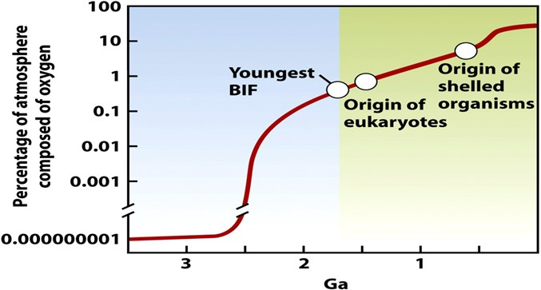



**The Proterozoic Eon**

* Continental collision created Precambrian supercontinents.
  + Rodinia – Formed ~ 1 Ga.
  + The Grenville orogeny formed an extensive mountain belt.
* Pannotia – A short‐lived supercontinent ~ 570 Ma.



**The Proterozoic Eon**

* Atmospheric oxygen (O2) skyrocketed 2.4 to 2.2 Ga.
  + Currently, O2 is 21% of the atmosphere.
  + Before 2.2 Ga, detrital pyrite in sediments indicated no O2.
  + Redbeds (red from Fe‐oxides) don’t appear before 2.2 Ga.
  + Banded iron formations (BIFs) – Fe dissolved in the ocean reacted with O2, forming worldwide iron oxide deposits.

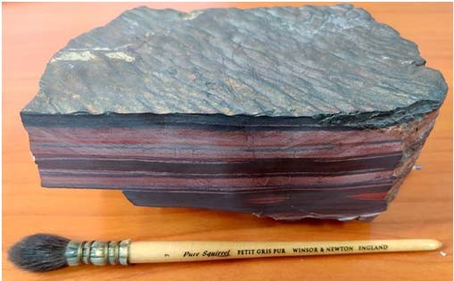



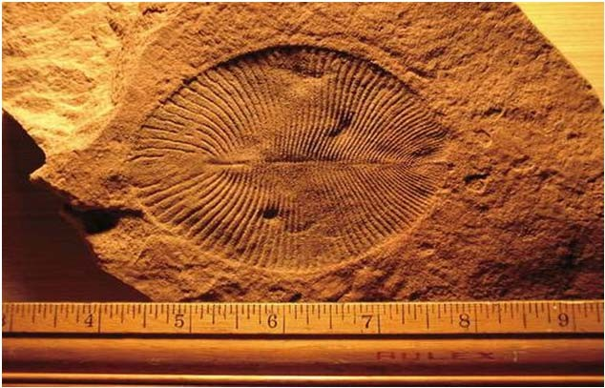

**The Proterozoic Eon**

* Atmospheric O2 permitted diversification and multicellular of life (~500 Ma).
* Ediacaran fauna – Unusual soft‐bodied fossils.
  + Preserved in end Proterozoic sediments; Multicellular invertebrates resembling worms and jellyfish.
  + Two events: assembly and break‐up of Pannotia; Global cooling



**The Phanerozoic Eon**

* Phaneros = visible; zoic = life.
* The most recent 542 Ma of Earth history.
  + Began with appearance of diverse hard‐shelled organisms.
    - Hardshells vastly increased fossil preservation.
    - Made possible a more complete archive of life on Earth.
* The Phanerozoic is divided into 3 eras.
  + Paleozoic – Ancient life (Trilobites, Nautiloids).
  + Mesozoic – Middle life (Brachiopods, Dinosaurs).
  + Cenozoic – Recent life (early Horses, Mammoths..).
* Eras emphasize changes in Earth’s biota.

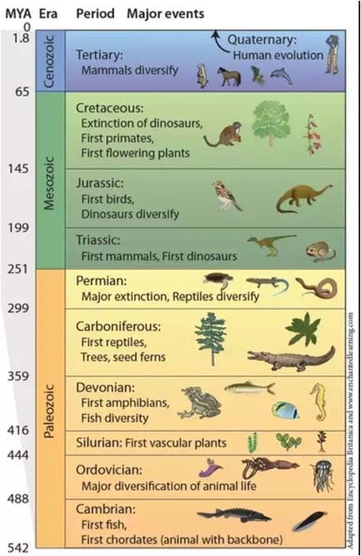

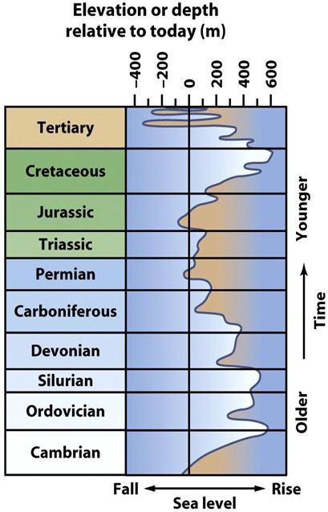



**The Proterozoic Eon**

* Tectonic plates and continental blocks rearranged.
* New supercontinents formed and rifted apart.
* Numerous orogenic belts were created and eroded.
* Phanerozoic sea level (SL) has changed often.
* High sea level flooded continental interiors (sediment deposition).
* Low sea level exposed continental margins (erosion or nondeposition.)



**The Proterozoic Eon**

* Rearrangements of the continents

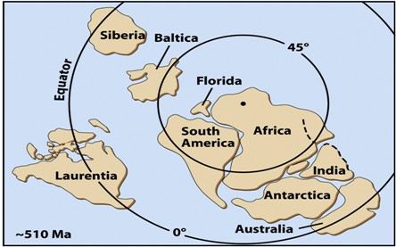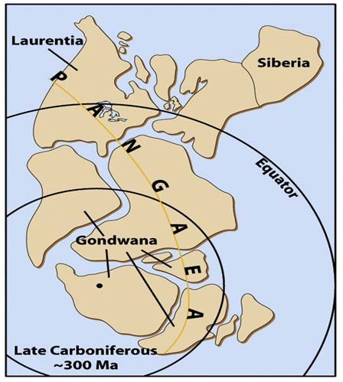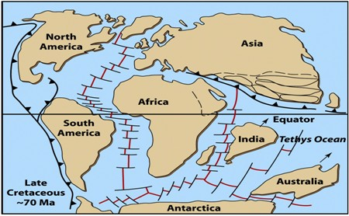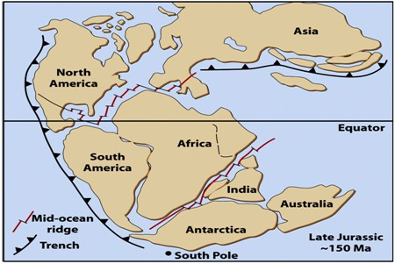



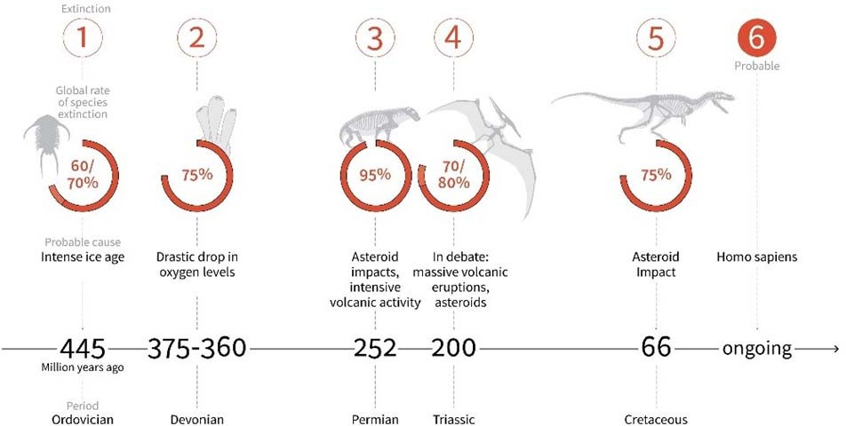

**The Proterozoic Eon**

Global Mass extinctions

More than 99 % of all organisms that have ever lived on Earth are extinct.

Palaeozoic

Mesozoic

Cenozoic



**Next Lecture**

Methods of Numerical Age Dating

# Isotope Geochemistry

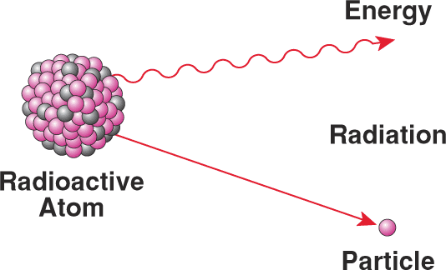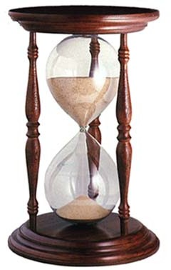

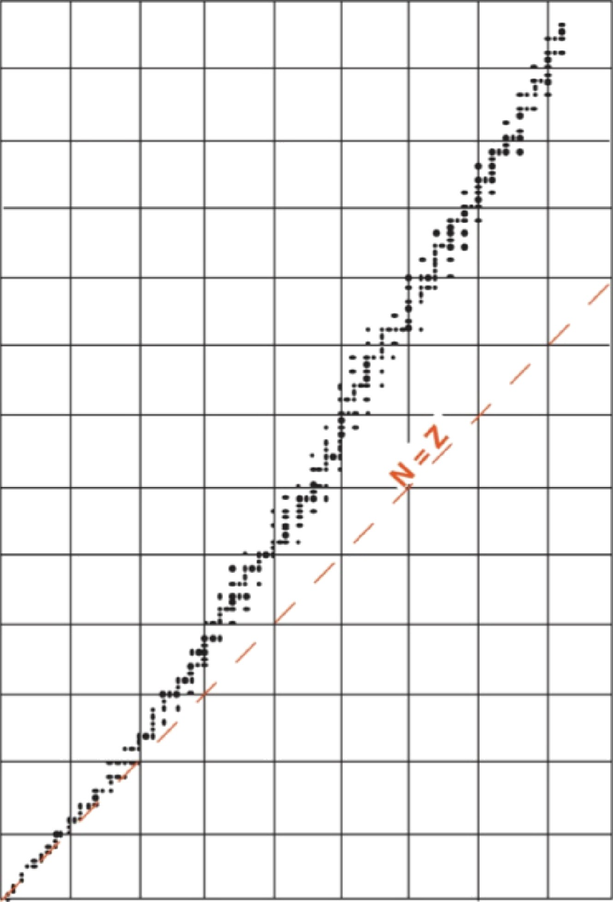130

12D

110

100

9D

80

ron number

60

N, nwe

50

40

20

10

0 10 20 30 40 30 60 70 80 90

Z, proton number

**I-b Properties of nuclides**

* Mass:

The mass of a nuclide is given in amu (atomic mass unit)

Definition: M(12C)=12 amu

mproton≈mneutron≈1 amu

* The mass of one atom of carbon 12 (12C) is determined by mass spectrometry and is equal to 1.9922x10-23 g
* Electrostatic repulsion vs. nuclear attraction

Electrostatic repulsion

Proton

Proton

If close enough, strong nuclear force wins

Nuclear Force

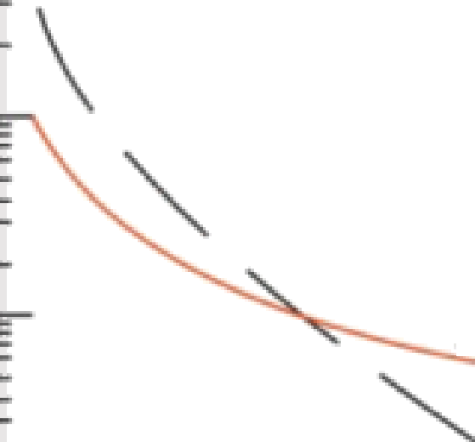1

|  |  |  |  |  |  |  |  |
| --- | --- | --- | --- | --- | --- | --- | --- |
| u °  0°*  0^* | Electromagnetic | | | | | | |
| —7 | » | ] | Nuclear  I | I | **• | I |  |
| “•* |
| 0 |
| —10 |

1

1

1

1

1

g

0 0.2 0.4 0.6 0.8 1.0

Dis@nce, 10- * m

Figure 1.2 The nuclear and electromagnetic potential of a proton as a function of distance from the proton.

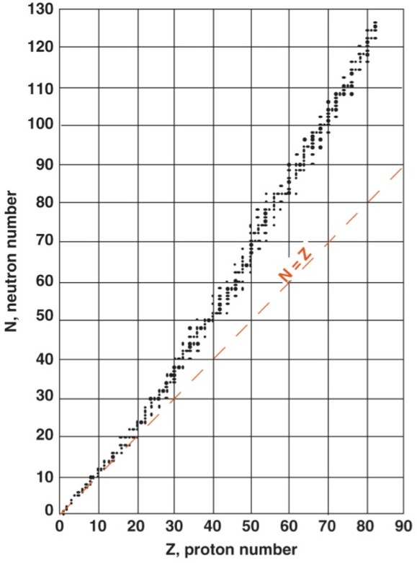The elements deviate from the 1:1 line

As the number of protons increases in a nucleus, the electromagnetic force increases faster than the strong nuclear force.

Therefore larger atoms needs

more and more neutrons to remain stable.

**II. Natural Radioactivity**

* Radioactivity is the emission of particles from unstable nuclei. Radioactivity allows a nucleus to evolve from an unstable state to a more stable configuration.
* The emitted particles by radioactivity are of three types: α β γ. α= 4He nucleus;

β-= electron or β+= positron;

γ= photons

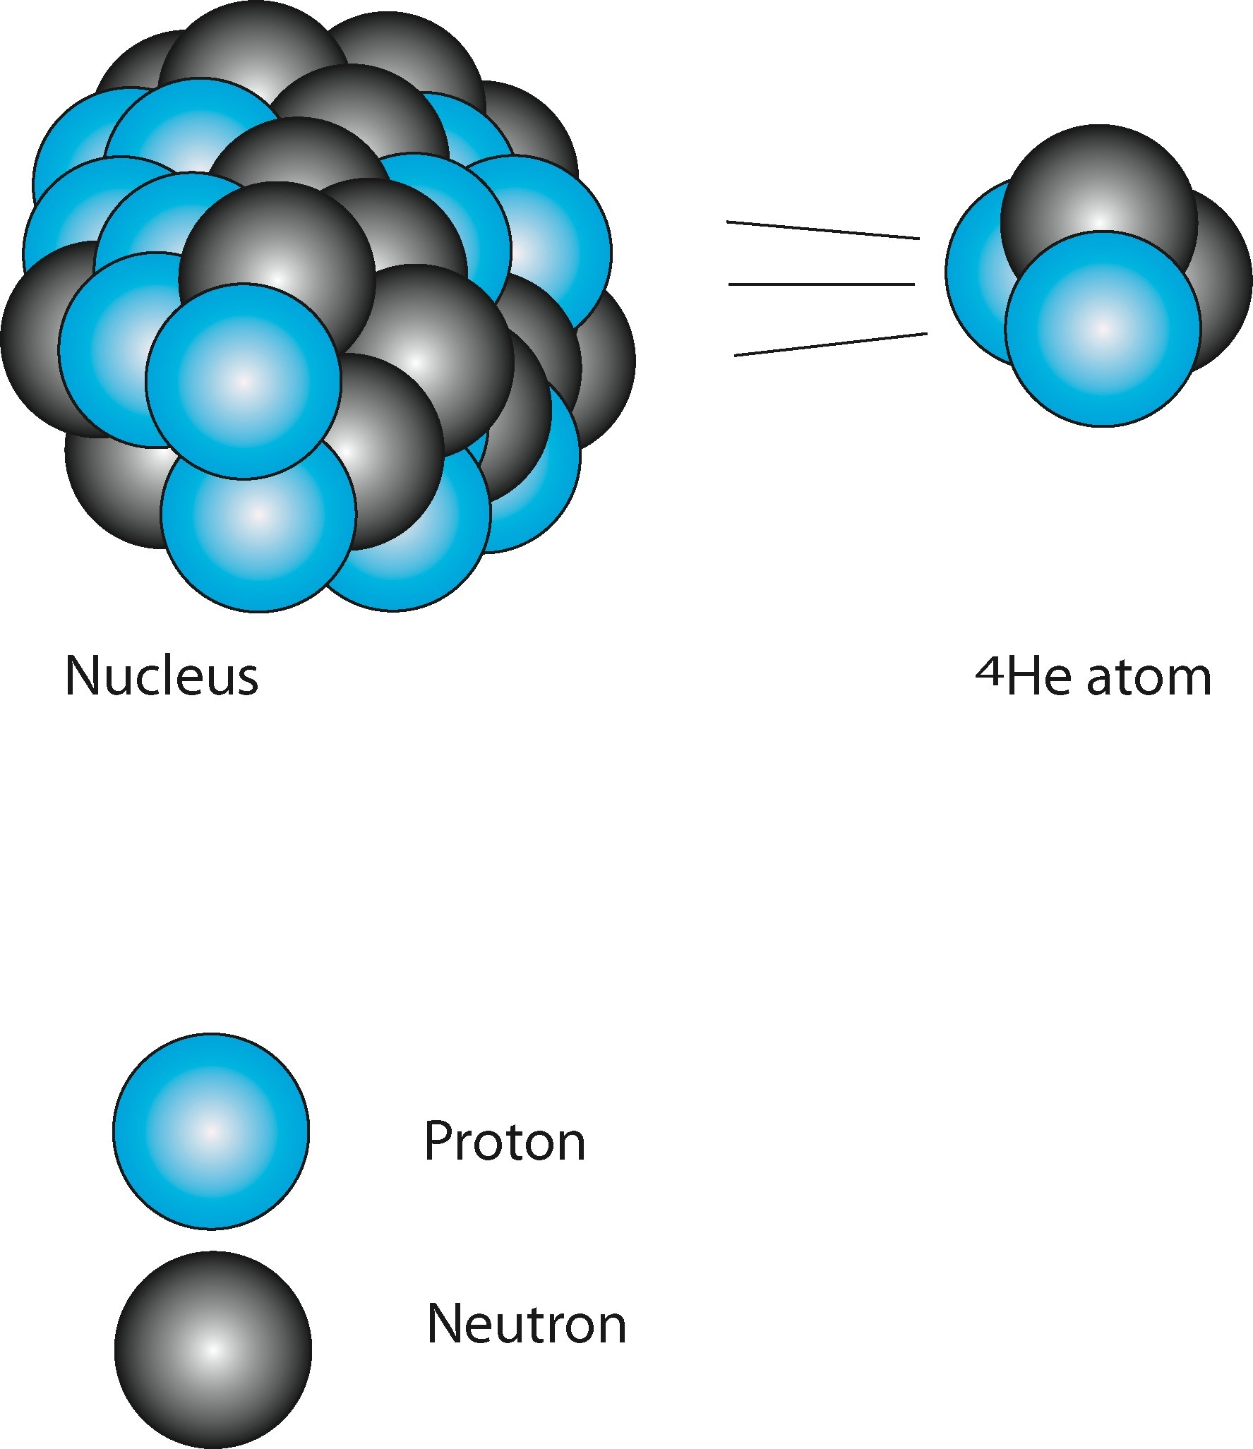** decay

* Occurs for unstable nuclides with A  56 (except 5He, 5Li and 6Be)
* Consists of 2 proton and 2 neutron

|  |  |  |  |
| --- | --- | --- | --- |
|  | ***Atomic No.*** | ***Neutron No.*** | ***Mass No.*** |
| ***Parent*** | Z | N | Z+N =A |
| ***Daughter*** | Z-2 | N-2 | Z-2+N-2 = A-4 |

238

234 **4**

92 U

90 Th

**2 He**

Energy

** decay

Emission of an α particle =4He nucleus (2 neutrons, 2 protons)

The number of nucleons A decreases by 4 and its Z by 2.

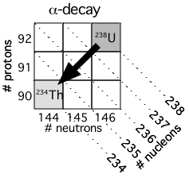

Example: 238U -> 234Th + 4He Mass balance:

238U 238.0508 amu

234Th –234.0436 amu

4He –4.00260 amu

Mass defect 0.0046 amu

= 6.86x10-10 J/decay

= 1.74x1012 J/g 238U

=~480,000 KW-H (1.6 Billion BTUs)

This is the principal mode of decay of heavy isotopes such as U, Th, 209Bi

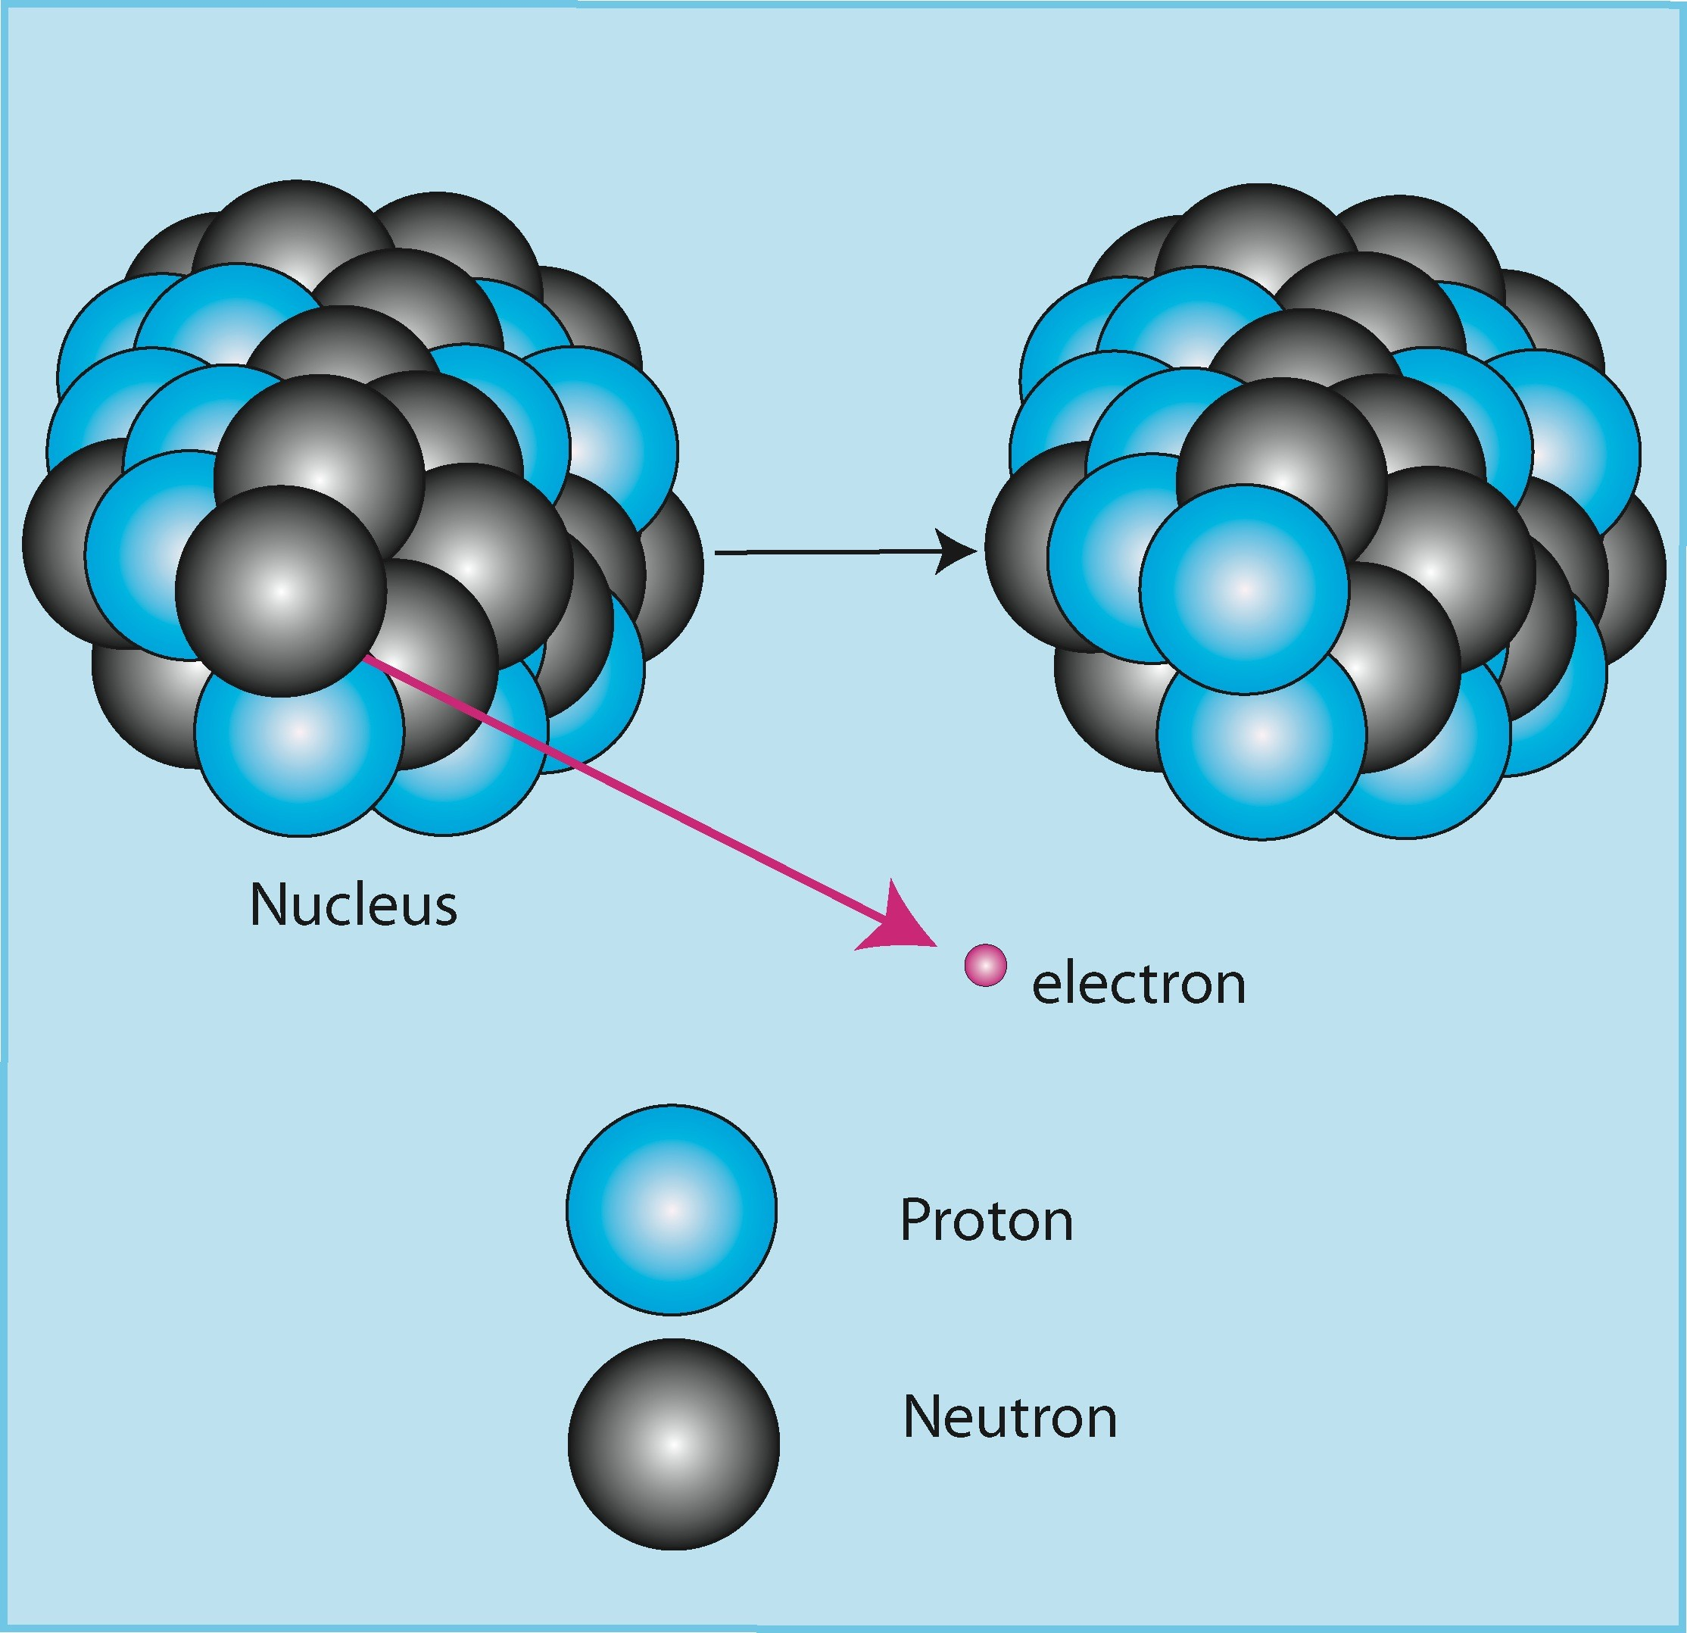**- decay

Decay by emitting a negatively charged beta particle

Neutron = Electron and Proton

|  |  |  |  |
| --- | --- | --- | --- |
|  | ***Atomic No.*** | ***Neutron No.*** | ***Mass No.*** |
| ***Parent*** | Z | N | Z+N =A |
| ***Daughter*** | Z+1 | N-1 | Z+1+N-1 = A |

40

19 K

40

20 K

### Energy

β− **decay**

Emission of an electron (and an antineutrino) during the conversion of a neutron to a proton

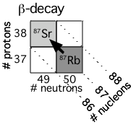The number of nucleons does not change. The atomic number increase by one:

Example: 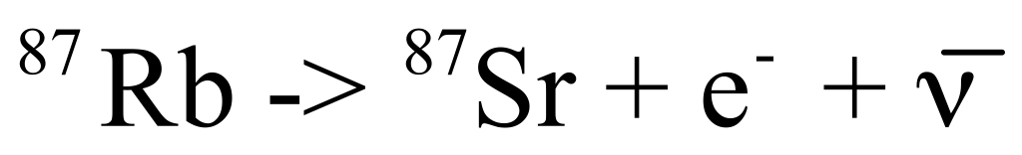

This is the preferred mode of decay for nuclei with an excess number of protons relative to the stability valley.

β**+ decay and electron capture**

* + 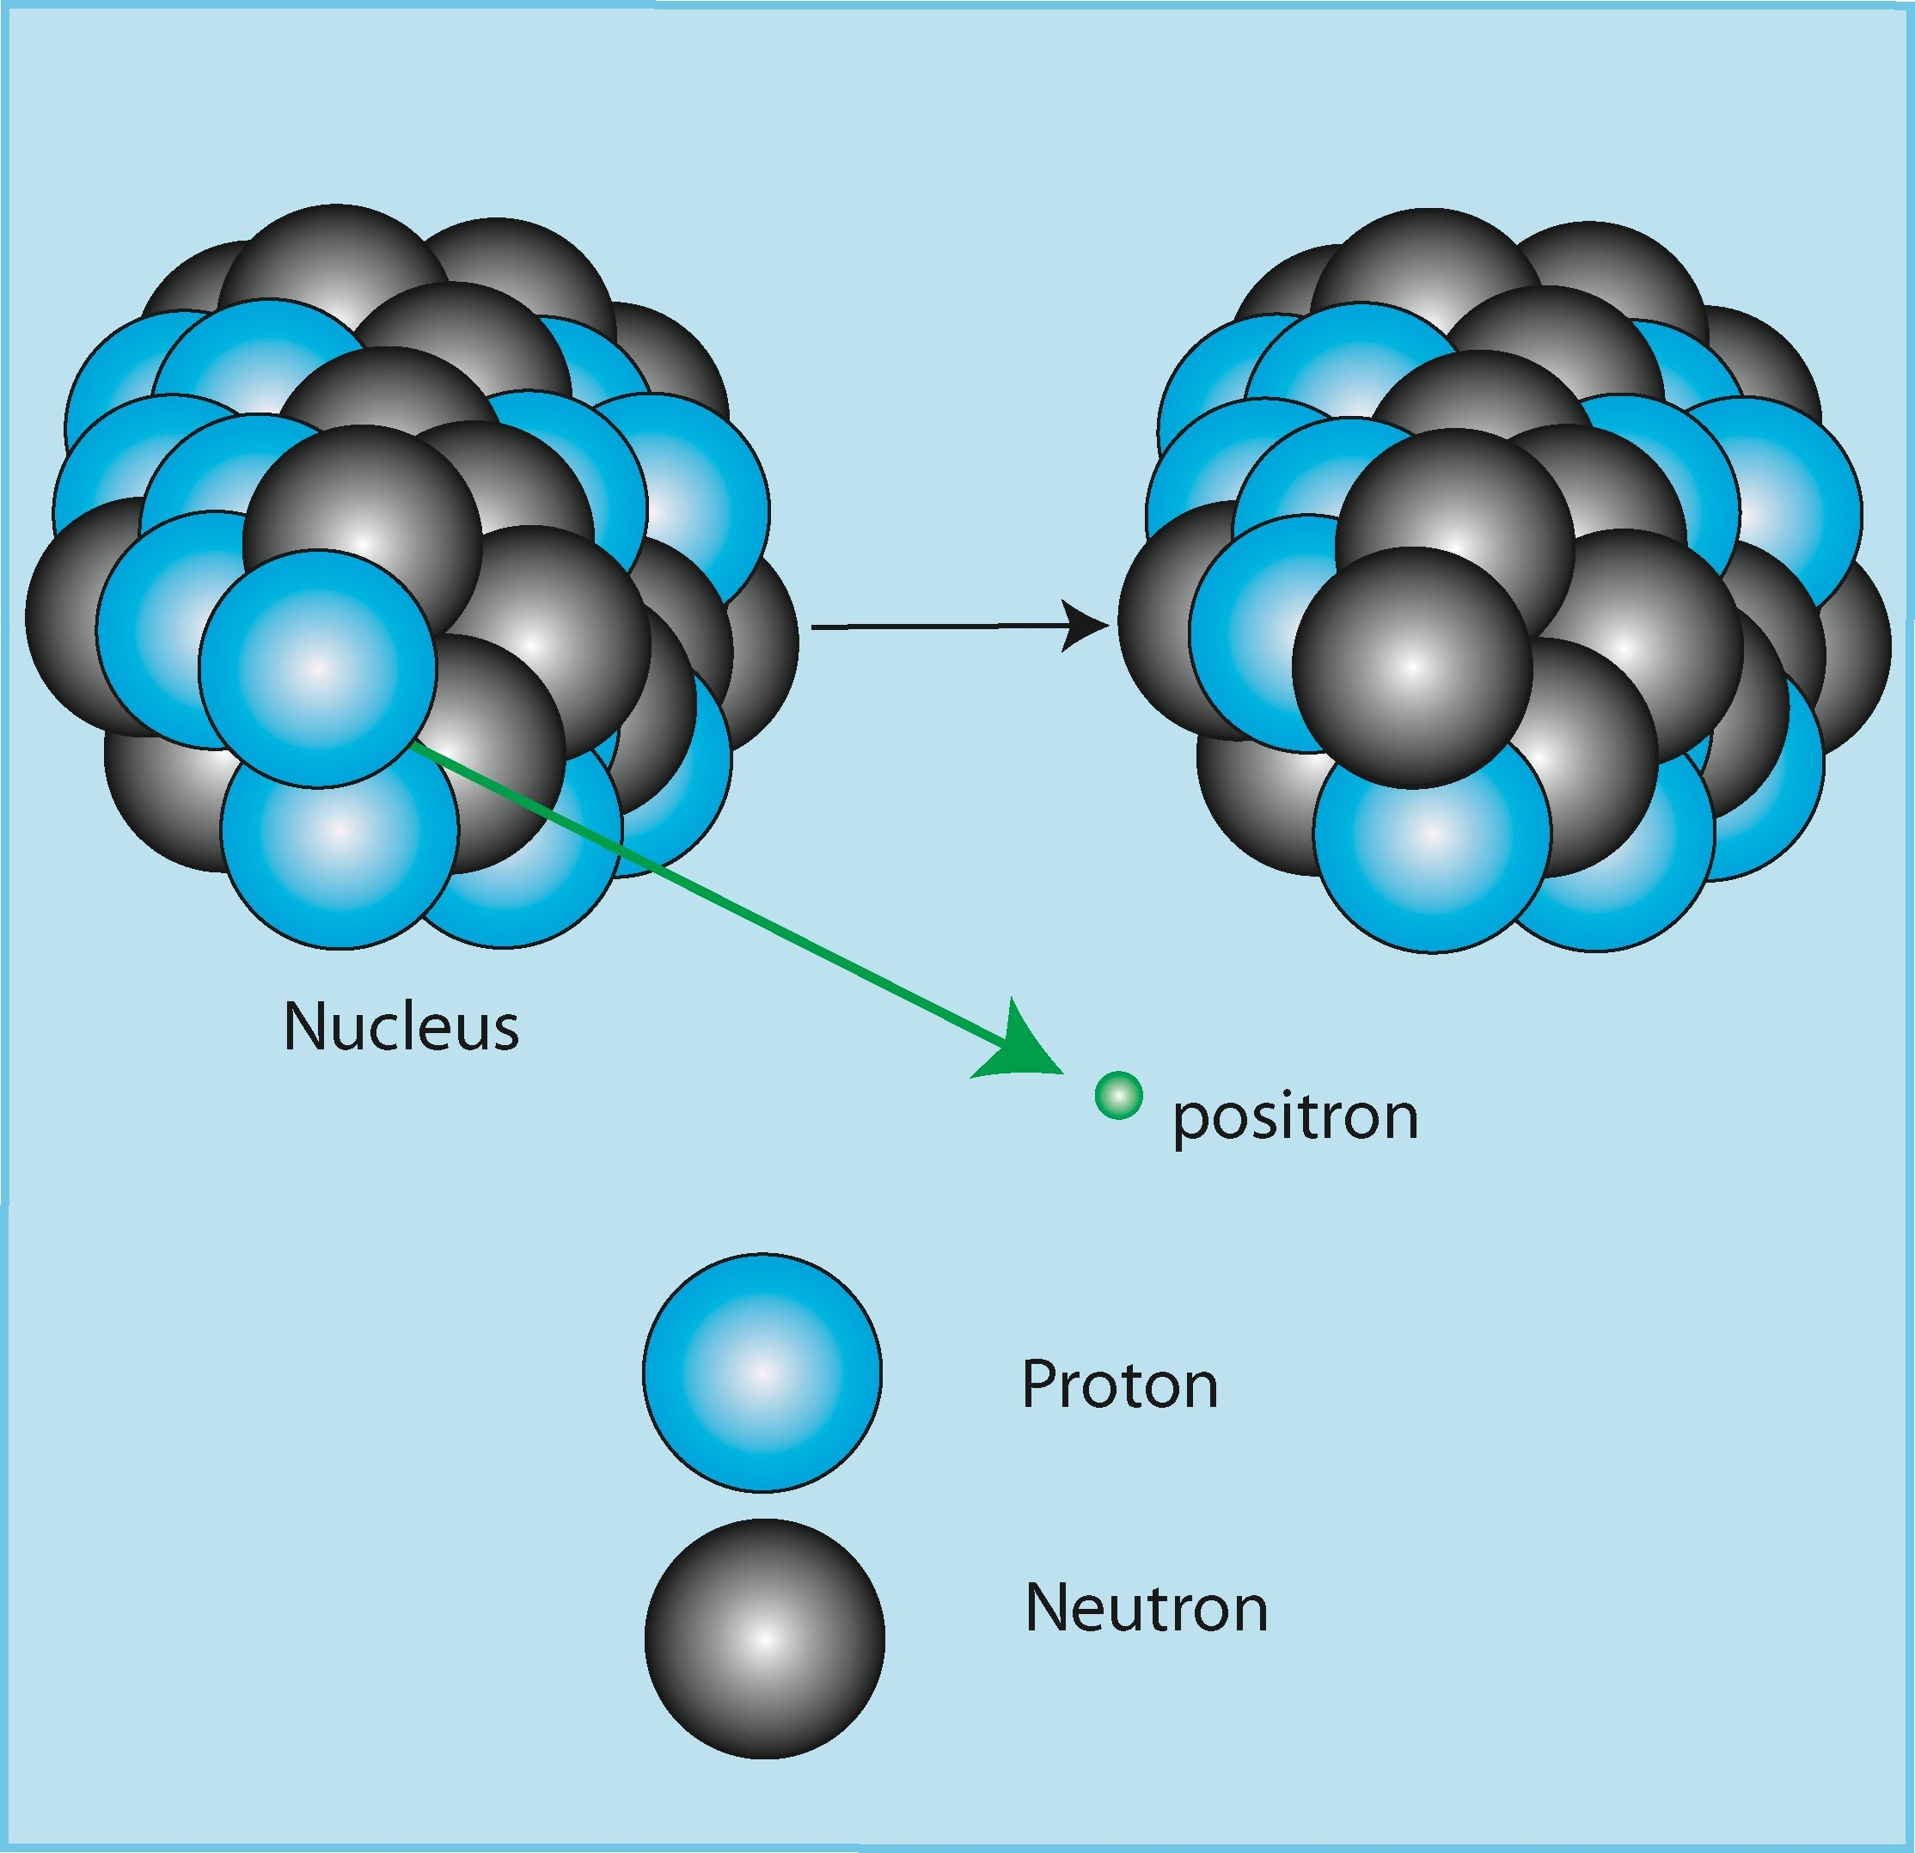A proton transforms into a neutron with emission of a positron and a neutrino:

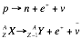

β **decay and electron capture**

Emission of a positron (and a neutrino) *or* capture of an electron from an internal layer. This is the conversion of a proton into a neutron

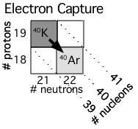The number of nucleons does not change. The atomic number decreases by one :

Examples:

4019K-> 4018Ar + e-+ *v*

These are the decay mode for nuclei with an excess of protons relative to the stability valley.

# Central path of stability

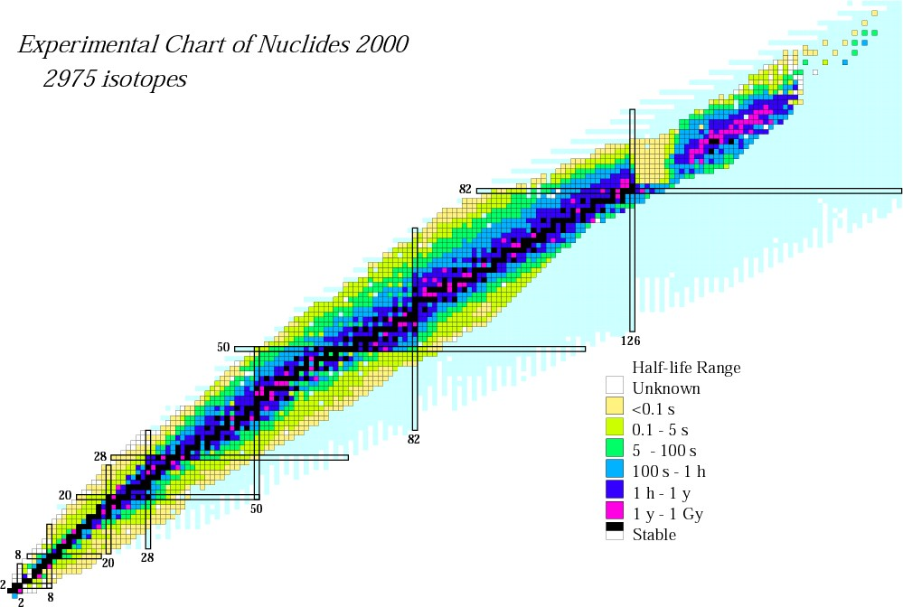

This table represents all the known nuclides. The stable nuclides are shown as black dots.

**NUCLIDE CHART**

**Z** The stability of a nucleus depends on its ratio of N/Z

**N** Stable nuclides plot along a central path of stability At low masses, N/Z  1 (Z=N)

At high masses, N/Z  3

**NUCLIDE CHART**

**Chart of nuclides (2)**

Number of protons

Number of neutrons

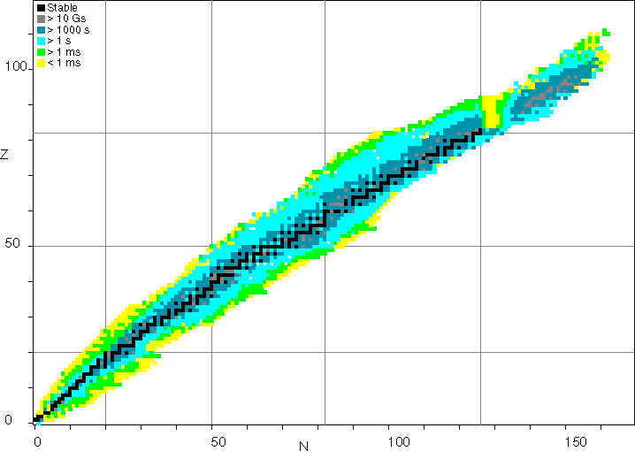

α

β+ or EC

β-

# Isotopes

Radiogenic Isotopes Geochemistry

Stable Isotopes Geochemistry

***Dating with Radioactivity***

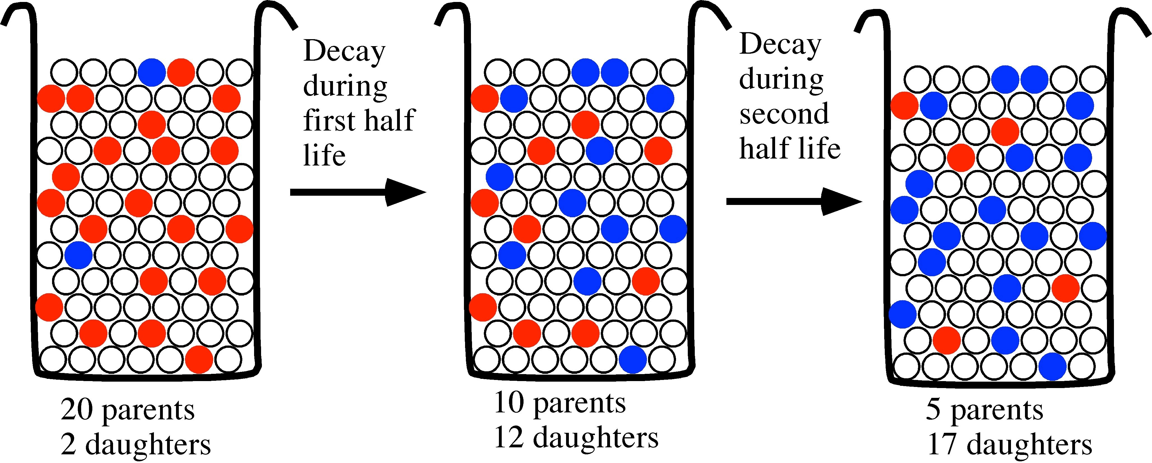

***The actual number of atoms that decay (radioactive parent) continually decreases and the number of stable daughter atoms (radiogenic daughter) increases.***

***Simp/e Radioacfiue Decay***

Radiu:ictivc decay is a stnchastic prncess linketl tn the stability of nuclei. "l“he ate uf change in the number of radiuacti›v nuclei is a ftmction nf the total number nf nuclei present and the decay cunstant i..



’I“he sign un the left hand is negative because the number of nuclei is decreasing. Rearranging this equation yields



and in1egr:iting yields

- In N — ?. t - k*

L” is the integmtion cunstant. We sulve for C by setting .N Nil and t t0. "1“hen

C-- !nN 0

Substituting for L” gives We rearrange Rearrange again

Eliminate the natiza1 lug

And rearrange

**...continue...**

Unfortunately, we don’ t know N0 a priori, but decayed N have produced radiogenie daughters D*.

Therefore

Replacing N0 with N e t yields

D* = N0 — N

D* = N e t N

Rearranged D* = N (e ' — 1) or, for small k t, D* = N k t ,

The number of daughter isotopes is the sum of those initially present plus those radiogenically produced.

D = D + D*

Therefore, D = D0 + N (e ' — 1) or, for small k t, D = D0 + N k t ,

This is the basic radioactive decay equation used for determining ages of rocks, minerals and the isotopes themselves. D and N can be measured and X has been experimentally determined for nearly all known unstable nuclides. The value D0 can be either assumed or determined by the **isochron method.**

How to obtain a “half-life”?

The rate of decay of a radioactive parent nuclide to a stable daughter product is proportional to the number of nuclides present at any time (Rutherford and Sody, 1902)

1. 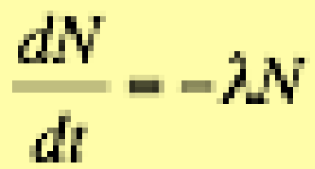whereby N is number of nuclides , t is time and λ is the decay constant

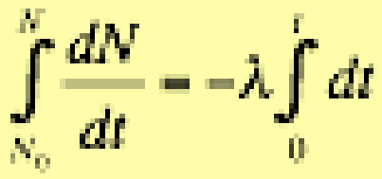Integration of 1

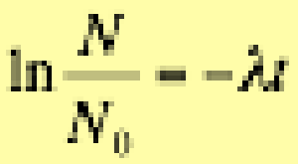results in (2) which can be rewritten as

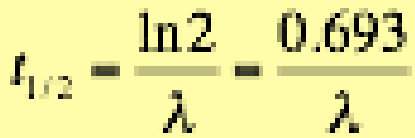(3) Half life: N=N0/2 and t=t1/2

### Points to Remember

###### -dN/dt = N

N= # atoms of the radioactive nuclide, t = time,

● = decay constant = probability that an atom will decay in a unit time

*N = N0e-t*

###### t½ = (ln 2) /  = .693/

*N0 = N at t=0*

Half-life = time it takes for half a sample to decay (t when N = ½N0)

###### D = D0 + N(et –1)

D* = radiogenic daughter = # daughter atoms produced by radioactive decay of a parent, P (D = D0 + D*)

Divide by a stable, non-radiogenic isotope of the daughter element to get ratios e.g. for 87Rb  87Sr + - :

87Sr/86Sr = (87Sr/86Sr)0 + 87Rb/86Sr (et –1) [Example]

*Simple Decay: Radioactive Parent m• Stable Daughter*

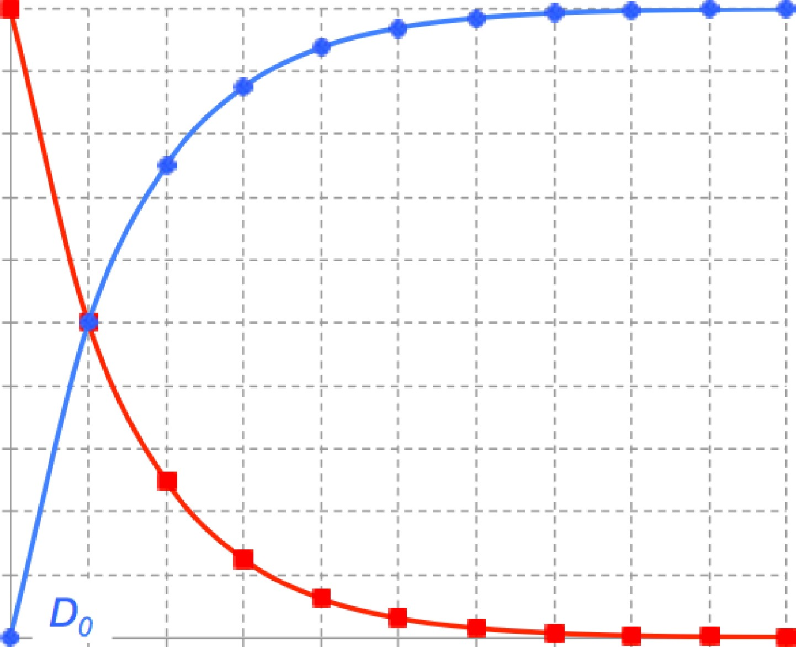1000

Number of Atoms (N or D*

900

800

700

600

500

400

300

200

100

0

0 1 2 3 4 5 6 7 8 9 10

Half-lives

ingrowth of daughter

*D* Nd (1 - e-’)*

*N Nq e-’*

decay of parent

**87Rb-87Sr decay equation (widely used in river geochemistry)**

87 *Sr*

  87*Sr* 

 87 *Rb * 

  (*e t* 1)

*Rb/Sr=*

*Rb/Sr=1.2*

*0.8*

*ROCK*

*(87Sr/86Sr) i= 0.702*

*Rb/Sr=0.6*

*MANTLE*

*87Sr/86Sr = 0.702*

*i*

86*Sr*

 86*Sr*  86*Sr*

*measured measured*

*when you crystallize a rock, you will always have some Sr present*

*t=Time of crystallization*

# Uses of Radiogenic Isotopes

#### Age Determination

* Source Identification
* Mixing Calculation

Dating

We can use the radioactive decay equation to calculate the age of a sample. We can measure the present day ratios and , but we still have 2 unknowns: R0 and t. What can we do?

1. Assume zero initial daughter. This approach can be valid if you know something about mineralogy. For example, zircons are often used for U-Pb dating because the mineral incorporates U, but not lead. Therefore any Pb measured is radiogenic. Similarly, micas accept Rb but not Sr. Another example is K-Ar dating of volcanic rocks. Ar, the daughter, is lost upon eruption, and the only Ar present is radiogenic Ar.
2. Use 2 different isotope systems. For example, if you know what the age should be from a system where you think you know the initial daughter ratio (e.g. U-Pb), you can calculate the initial daughter ratio.
3. Assume one and calculate the other. If we assume the initial ratio and calculate an age, it is called a “Model Age”
4. Use an isochron diagram

# The Isochron

The radioactive decay equation is in the form of a line: D = D0 + P(et-1) … y = b + xm

Plot D ratio vs. P/D for several comagmatic or cogenetic samples and draw a best fit line through the data

y-intercept = initial D ratio, slope is related to t

This line is called an “**Isochron**”

Represents true age if:

* 1. The system was at isotopic equilibrium at time *t* = 0.

I.e. all the samples formed with the same initial daughter isotope ratio

* 1. Closed system since formation

Whole-rock isochron represents age of formation Mineral isochron represents age of last metamorphosis

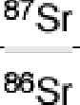

Initial 7SF

|  |  |  |  |  |
| --- | --- | --- | --- | --- |
|  | Start by plobing three rocks with di#erent Rb contents at time ›D  time = | | | |
| Rock A | | Rock | B | Rock C |

ratio ggs f

tg



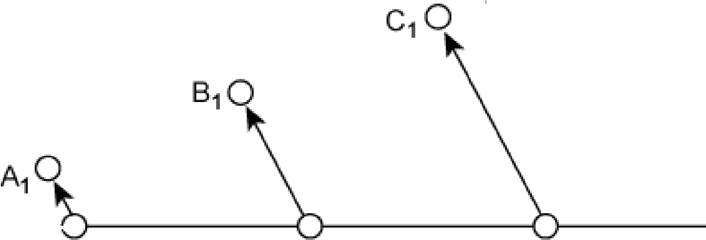Initial 7SF

|  |  |  |  |  |
| --- | --- | --- | --- | --- |
|  | At time ‹1, some arbitrary time aQer time q, some of the BZRb has decayed to B7Sr. The more  Rb in the rock the more B/ Sr is  produced  time = ›1  time = | | | |
| Rock A | | Rock | B | Rock C |

ratio ggs f

tg



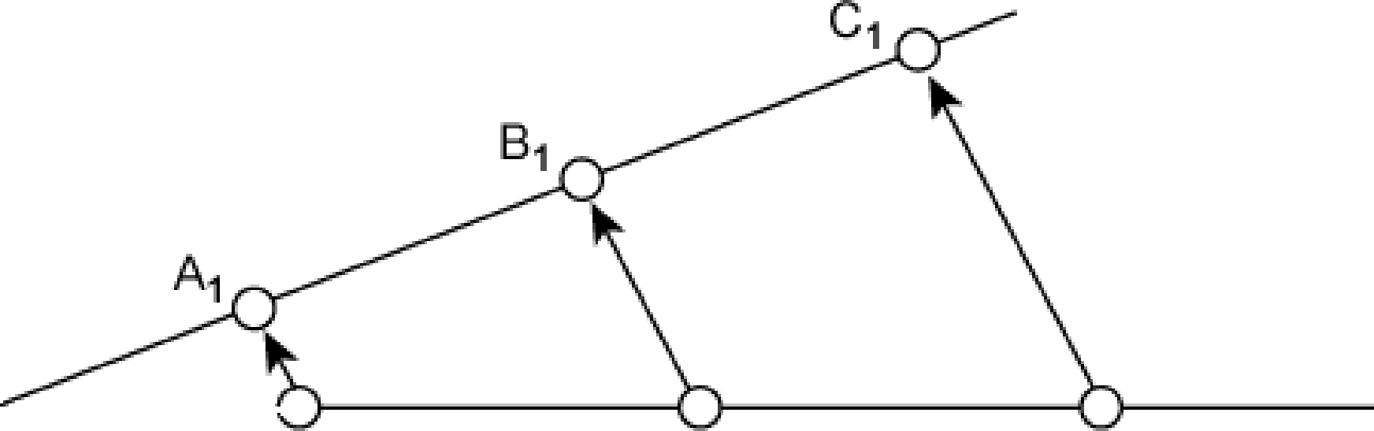Initial 7SF

|  |  |  |  |  |
| --- | --- | --- | --- | --- |
|  | If a straight line is fitted to these evolved points at time ›1. they also fall on a straight line that  has the same initial 87Sr/ BbSr  ratio as at time It.  time = r1  time = | | | |
| Rock A | | Rock | B | Rock C |

ratio ggs f

tg

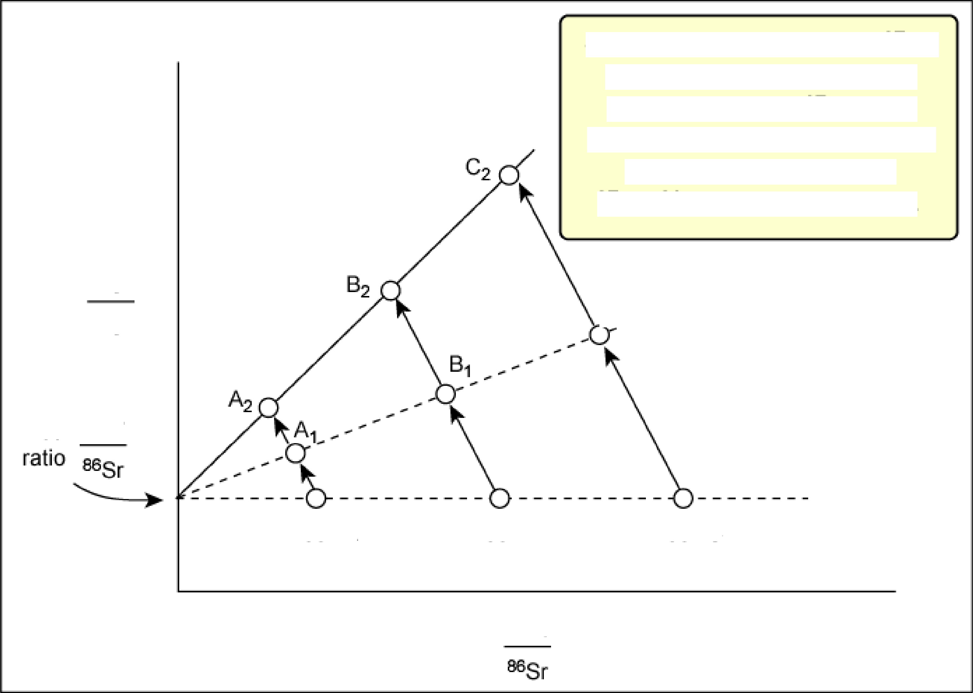Similarly aRer time fy, the B7Rb in the three rocks will again have decayed to BJSr but a

time = straight line through the points

will give the same initial

B7Sr/ 86Sr ratio as at time ip.

^Sr

^'Sr

Initial 7SF

C1, . time = ›1

Rock A

Rock B

^7Rb

Rock C

time = tg

One rock with four di#erent minerals each with diñerent Rb/Sr ratios. Also evolve so that they lie along a steeper but still linear line going through the same initial 8 Sr/^^Sr ratio

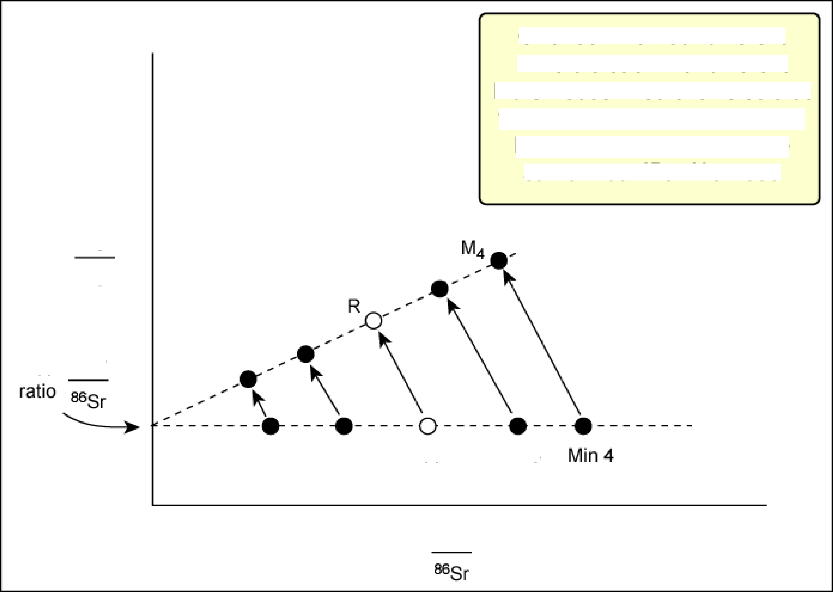

, - time = ›1

My

M 2

Initial 7SF Mt

time = tg

Min 1 Min 2 Rock Min 3

^7Rb

# The initial ratio

* How do we know if a series of sediments are co- genetic?
* For sediments to be co-genetic, implies that they are derived from the same parent material.
* This parent material would have had a single

87Sr/86Sr isotope value, ie the initial isotope ratio

* Therefore, all samples derived from the same parent magma should all have the same 87Sr/86Sr isotope ratio
* If they don’t, it implies that they are derived from a different parent source.

Two sui†es of seeiples

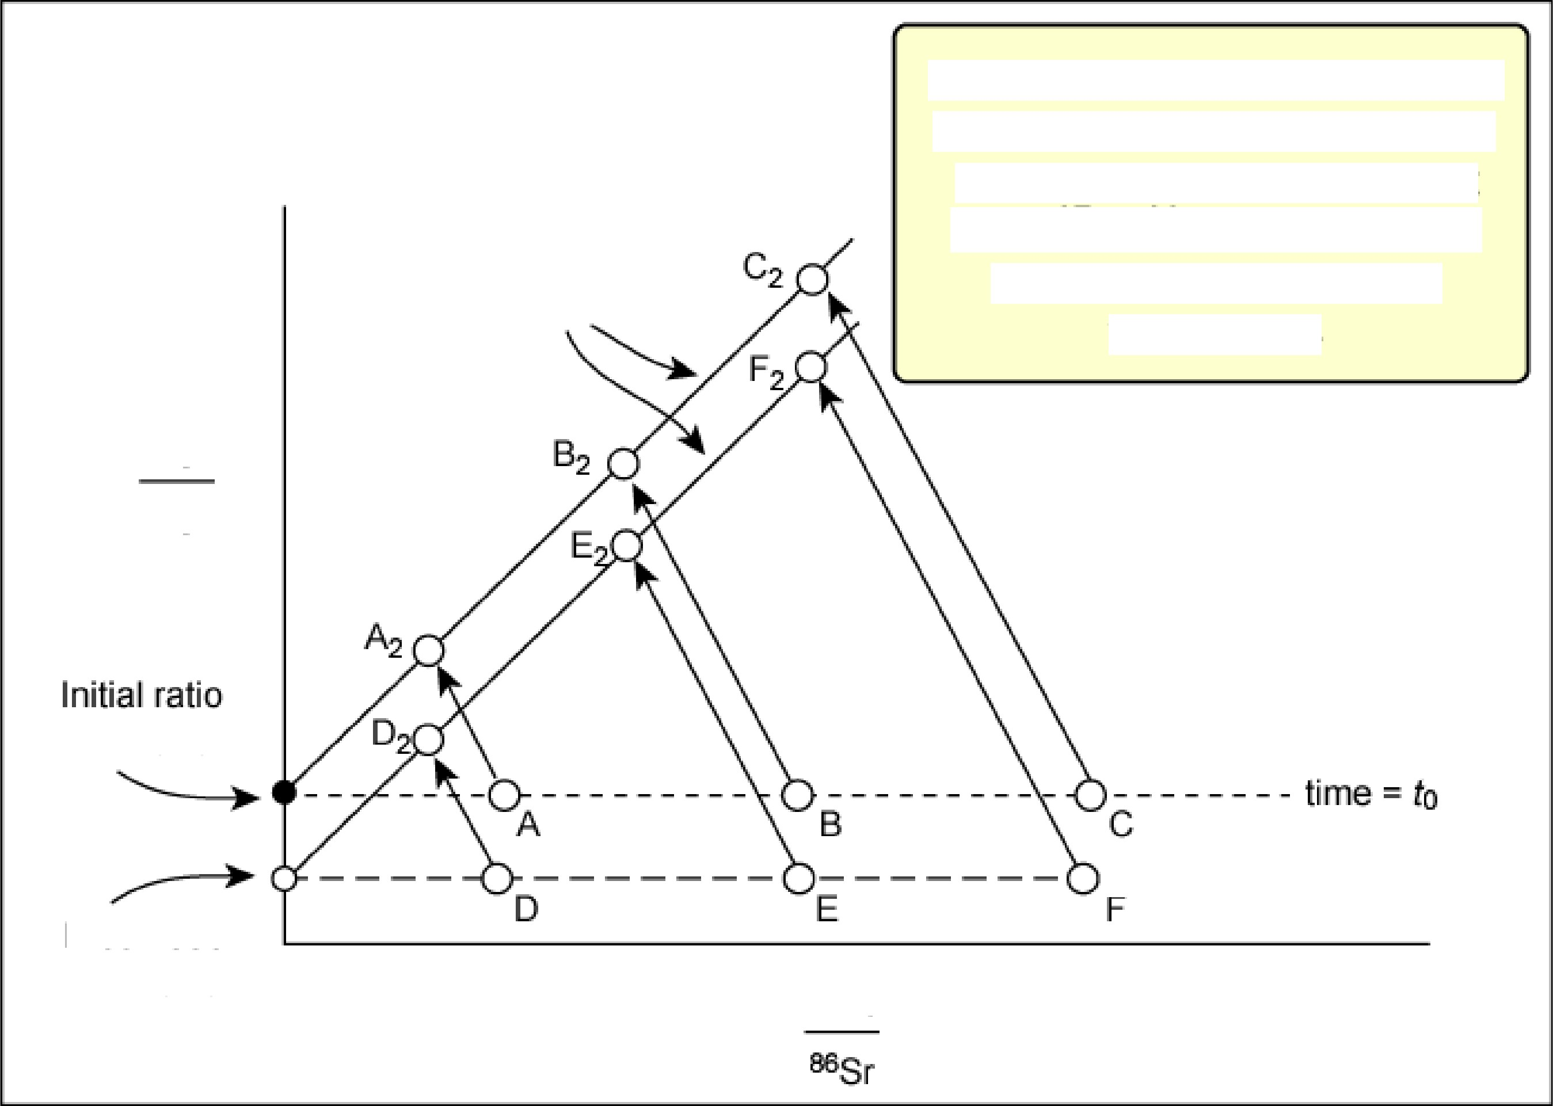

†ho† ore not co-qenetic

time = ›2

Rocks A - F have the same age and thus have the same slope. However, they have diñerent initial ^*Sr/B^Sr isotope ratios indicated by the diñerent

y-intercepts

rocks A, B, C

Initial ratio

rocks D, E, F

^7Rb

————— - time =›

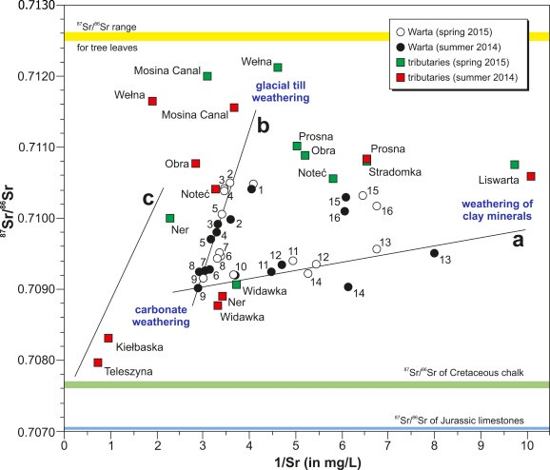

Zieliński et al., 2017

Mixing Theory

* Geochemistry often tries to model variations in

measured composition as the result of mixing of a small number of *components* [N.B. a different use of component from the thermodynamic usage] or *end*

members

* + This reduces highly multivariate data to a few manageable dimensions
  + It allows identification of the end members with particular source or fluxes, hence a meaningful interpretation of data
  + Many geochemical processes are easily understood in terms of mixing or unmixing:
    - river water + ocean water = mixing
    - primary liquid – fractionated crystals = unmixing
* We will work out the mixing relations for several spaces:
  + Element-element plots
  + Element-ratio plots (including elemental and isotope ratios)
  + Ratio-ratio plots 34

## Mixing Theory

* Mixing is simplest to see and understand when there are only two end members: *Binary mixing*
* For concreteness, instead of a bunch of general symbols, let’s do all this with two end members, *a* and basalt *b*, with the following compositions:

|  |  |  |
| --- | --- | --- |
|  | *a* | *b* |
| [Sr] | 100 ppm | 400 ppm |
| [Nd] | 2 ppm | 20 ppm |
| 87Sr/86Sr | 0.712 | 0.704 |

143Nd/144Nd 0.511 0.513

* The same relationships will apply for mixing of major elements as for trace elements.
* The same relationships will apply for ratios of major elements, ratios of trace element concentrations, and ratios of isotopes.

## Binary Mixing I: element-element

* This is the simplest case. Binary mixing in concentration-concentration space always generates *lines*.
* Let mixtures be generated with mass fraction *fa* of end member *a* and *fb* of end member *b*, such that *fa* + *fb* = 1.
* Then for two species, say Sr and Nd, we have conservation of atoms and mass in the form
* This can be written

[Sr]*mix* = *fb*[Sr]*b* + (1 – *fb*)[Sr]*a*

[Nd]*mix* = *fb*[Nd]*b* + (1 – *fb*)[Nd]*a*

[Sr]*mix* – [Sr]*a* = *fb*([Sr]*b* – [Sr]*a*)

[Nd]*mix* – [Nd]*a* = *fb*([Nd]*b* – [Nd]*a*)

* Dividing these two equations gives the equation of the mixing relationship in ([Sr],[Nd]) space:

*Sr*

*mix*

*Sr*

*a*

*Sr* *b* *Sr**a*



*Nd**b* *Nd**a*

*Nd*

*mix*

*Nd* 

*a*

#### Binary Mixing I: element-element

*Sr*

*mix*

*Sr*

*a*

*Sr* *b* *Sr**a*



*Nd**b* *Nd**a*

*Nd*

*mix*

*Nd* 

*a*

* This is the equation of a *line* with slope

*Sr**b* *Sr**a*

*Nd* *Nd*

*b a*

* Passing through points ([Nd]*a*,[Sr]*a*) and ([Nd]*b*,[Sr]*b*)



**Element-Element Plot**

450

400

350

300

*b*

1

0.9

0.8

0.7

0.6

250

0.5

*f*

200

0.4

*b*

0.3

150

100

50

0.2

*a*

0.1

0

0

5

10

15

20

25

30

35

**[Nd]**

## Binary Mixing I: element-element

* If you *know* the compositions of the end members, you can solve for *fb* using the lever rule:

*f*

*b*

*Sr* *mix* *Sr**a* *Nd**mix*  *Nd**a*

 

*Sr* *b* *Sr**a*

*Nd**b* *Nd**a*

* If you *don’t know* the end members, but only the data, what can you learn from a graph showing a linear correlation?
  + You can infer that if generated by mixing there are only two end members, otherwise the data would fill a triangle
  + You can infer that both end members lie on the mixing line, outside the extreme range of the data on both ends if they must have positive amounts (*additive mixing*)

## Binary Mixing II: Ratio

* In geochemistry we very frequently work with ratios, either isotope ratios or ratios of concentrations.
  + Sometimes a ratio is all you can measure accurately
  + Sometimes ratios have significance where concentrations are more or less arbitrary (example: during fractionation of olivine from a basalt, [Sr] will change because it is incompatible and the amount of liquid is decreasing, but [Sr]/[Nd] will not)
* You might think that the 87Sr/86Sr ratio of mixtures could be obtained in the same way as for [Sr]

(87Sr/86Sr)*mix* = *fb* (87Sr/86Sr) *b* + (1 – *fb*) (87Sr/86Sr) *a*

* You would be wrong!
* The isotope ratio of the mixture is going to be weighted by the concentration of Sr in each end member

– More generally, the weighting of ratios in the mixture is controlled by the denominator of the ratio, in this case 86Sr. 39

#### Binary Mixing II: Ratio

* Let’s do it right: we have

[87Sr]*mix* = *fb* [87Sr] *b* + (1 – *fb*) [87Sr] *a*

[86Sr]*mix* = *fb* [86Sr] *b* + (1 – *fb*) [86Sr] *a*

* Taking the ratio of these, we have

|  |  |  |  |  |
| --- | --- | --- | --- | --- |
|  87*Sr*   86    *Sr* *mix* |  | *fb* 87*Sr*  1  *fb* 87*Sr*  *b a* | | |
| *fb* | *Sr* *b*  1  *fb*  | *Sr**a* |

* And substituting [87Sr] = (87Sr/86Sr)[86Sr] for *a* and *b*:

|  |  |  |  |  |  |  |
| --- | --- | --- | --- | --- | --- | --- |
|  87*Sr*   86    *Sr* *mix* |  | *fb* | 86 |  87*Sr*  *Sr* *b*  86    *Sr* *b* |  1 *fb*  | 86  87*Sr*  *Sr**a*  86    *Sr* *a* |
| *fb*86*Sr*   1 *fb* 86*Sr*  *b a* | | | | |

* We can approximate this using [Sr] instead of [86Sr] as the weighting factors.

40

## Binary Mixing II: Ratio

* Now let’s consider plotting the isotope ratio of the mixture against an elemental concentration, perhaps [Nd].
* If we eliminate *fb* between the mixing equation for (87Sr/86Sr) and [Nd], we obtain the following equation (using the approximation Sr 

86Sr):

*A*

 87*Sr*





86

*Sr*



 *mix*

* *B*[*Nd*]

 87*Sr*

*mix*





86

*Sr*



 *mix*

* *C*[*Nd*]*mix*  *D*  0

*A*  [*Nd*]*b*[*Sr*]*a* [*Nd*]*a*[*Sr* ]*b*

*B*  [*Sr* ]*b* [*Sr*]*a*

*C*  [*Sr*]*a*  86

 87*Sr* 

 87*Sr* 



*Sr* *a*



[*Sr*]*b*  86



*Sr* *b*



*D*  [*Nd*] [*Sr* ]

 87*Sr* 

 87*Sr*

*a*

*b*





86

*Sr*



 *b*

[*Nd*] [*Sr* ]

*b*

*a*





86

*Sr*



 *a*

* Equation A*x* +B*xy* +C*y* + D = 0? 41

#### Binary Mixing II: element-ratio

* In general, element-ratio mixing generates a *hyperbola*.
  + The only case in which it is linear is B = [Sr]*b*–[Sr]*a* = 0



**Element-Ratio Plot**

0.713

0.712

0.711

0.71

0.709

0.708

0.707

0.706

0.705

0.704

0.703

0

*a*

0.1

0.2

0.3

0.4

*f*

*b*

0.5

0.6

0.7

0.8

0.9

0

5

10

15

20

25

1 *b*

30

35

**[Nd]**

* The index of curvature r = [Sr]*b*/[Sr]*a* tells you “how

hyperbolic” the hyperbola is going to be. 42

Binary Mixing III: Inverse Element-Ratio

* Although there is nothing special about the element-ratio case A/B vs. B (thus (87Sr/86Sr) vs. [Sr] is still hyperbolic), there is an especially useful test for mixing if you plot A/B vs. 1/B (in this case, (87Sr/86Sr) vs. 1/[Sr]).
  + Going back to our hyperbolic equation, if we replace [Nd]*mix*, [Nd]*a* and [Nd]*b* with [Sr]*mix*, [Sr]*a* and [Sr]*b* we have:

*A* 86

 87*Sr*

 *Sr* *mix*



* *B*[*Sr*]*mix*  86

 87*Sr*

 *Sr* *mix*



* *C*[*Sr*]*mix*  *D*  0

*A*  [*Sr*]*b* [*Sr*]*a*  [*Sr*]*a*[*Sr*]*b*  0, *B*  [*Sr*]*b* [*Sr*]*a*

 87*Sr* 

*C*  [*Sr*]

*a*





86

*Sr*



 *a*

 87*Sr* 

[*Sr*]

*b*





86

*Sr*



 *b*

  87*Sr*

 87*Sr* 



*D*  [*Sr*]*a*[*Sr*]*b*   86

  *Sr* *b*  *Sr* *a* 



−  86





* Or,

, which is a *line*.

43

*B* 86

 87*Sr*



*Sr* *mix*



* *C*  *D*

[*Sr*]

1

 0

*mix*

Binary Mixing III: inverse element-ratio

* Mixing in A/B vs. 1/B space always generates a line.

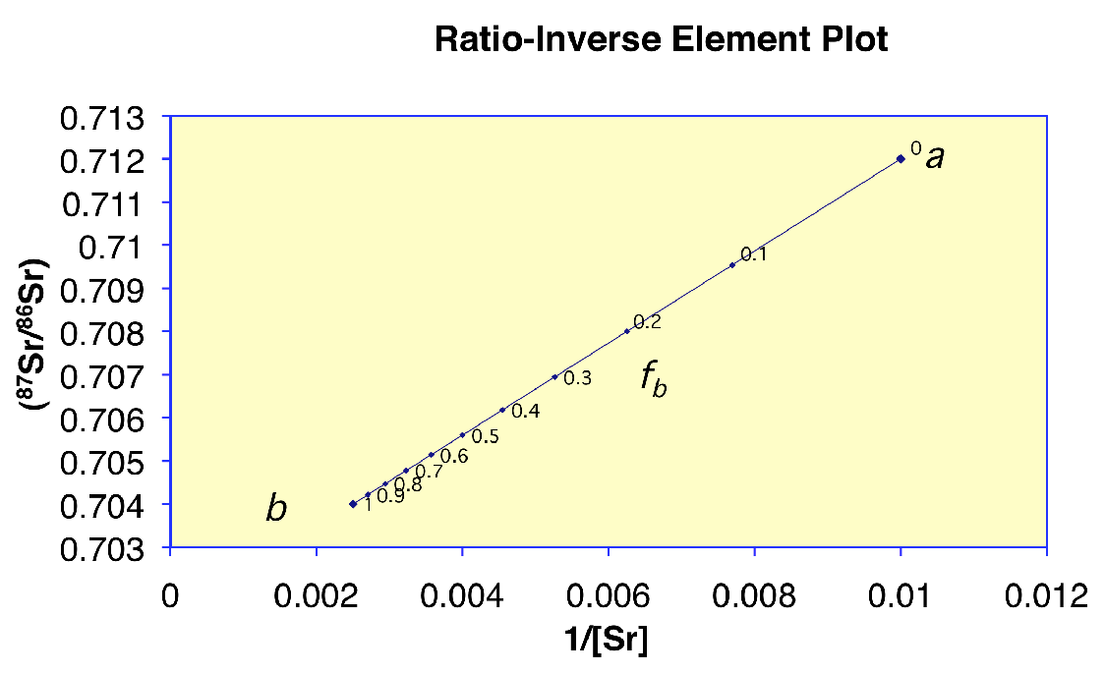

* The value of r = [Sr]*b*/[Sr]*a* now controls how hyperbolic the *spacing* of equal increments of mixing fraction are along the line. Since linear correlation is easy to calculate, it is much easier to test whether data are consistent with binary mixing in this space than in ratio-element space.

##### Binary Mixing IV: Ratio-Ratio

* Our final case is plots of ratios against ratios, whether isotope ratios, trace element ratios, or major element ratios.
* For example, let’s do (87Sr/86Sr) vs. (143Nd/144Nd).
* We now have two equations of the same form:

|  |  |  |  |  |
| --- | --- | --- | --- | --- |
|  87*Sr*   86*Sr*    | *mix* |  |  87*Sr*  *fb**Sr* *b*  86   1    *Sr* *b* |  87*Sr*  *fb* *Sr* *a*  86    *Sr* *a* |
| *fb**Sr* *b*  1 | *fb* *Sr* *a* |

|  |  |  |  |  |
| --- | --- | --- | --- | --- |
|  143*Nd*    144 *Nd*   | *mix* |  |  143*Nd*   *fb**Nd**b*  144    *Nd* *b* |  143*Nd*    1 *fb* *Nd**a*  144    *Nd*  *a* |
| *fb**Nd**b*  1 *fb* *Nd**a* | |

Where once again for the particular case of small variations in isotope ratios I have weighted by concentration rather than by the stable denominator isotope.

## Binary Mixing IV: ratio-ratio

* This time eliminating *fb* between the mixing equations gives

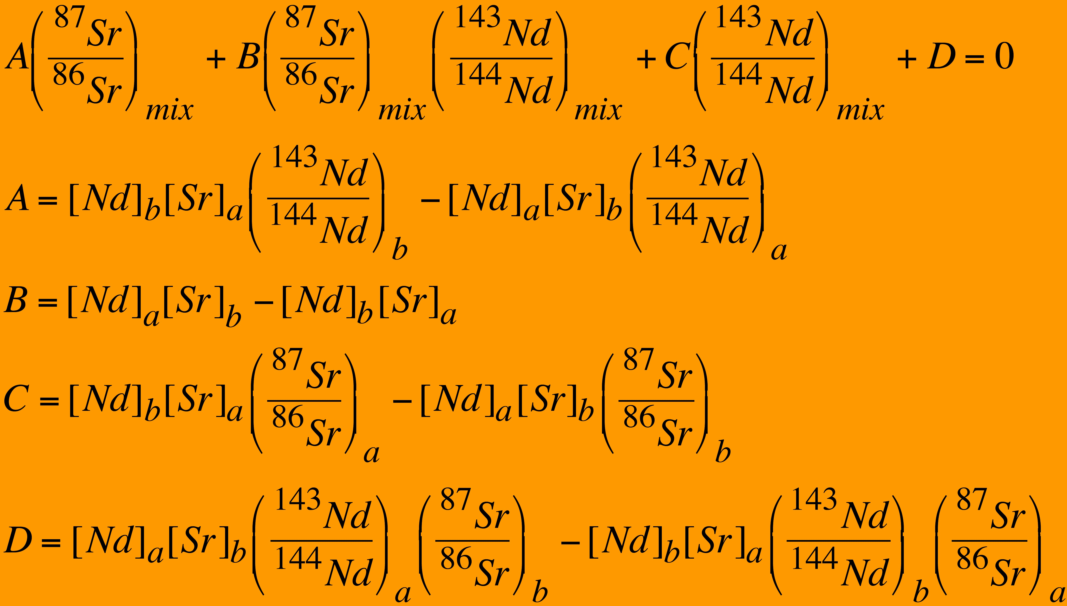

* Still a hyperbola. Now term B gives the curvature index
* *r* = ([Sr]*a*/[Sr]*b*)*/*([Nd]*a*/[Nd]*b*)

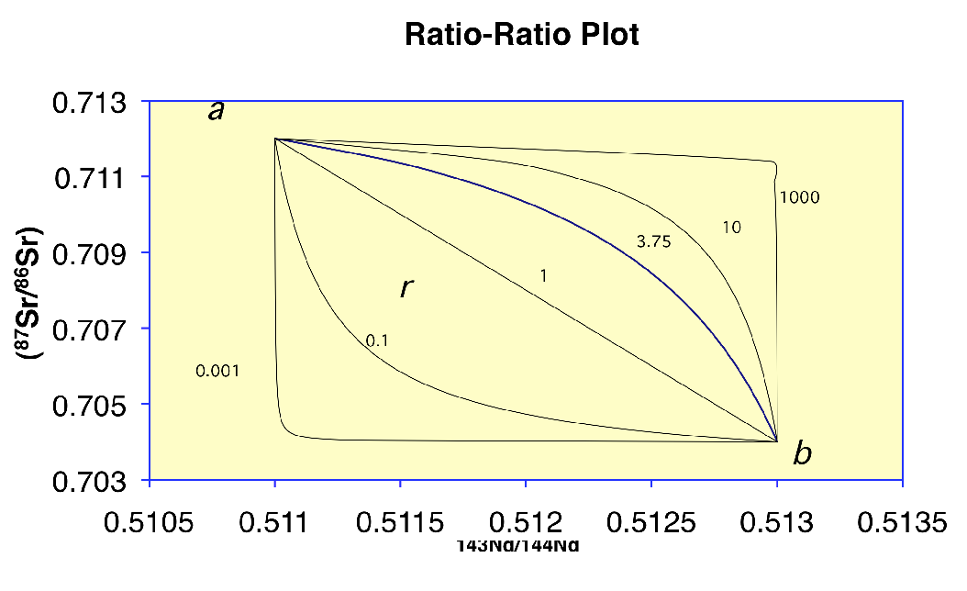Binary Mixing IV: ratio-ratio

This looks different from the element-ratio hyperbola because now the *spacing* of equal increments of mixing fraction is no longer regular.

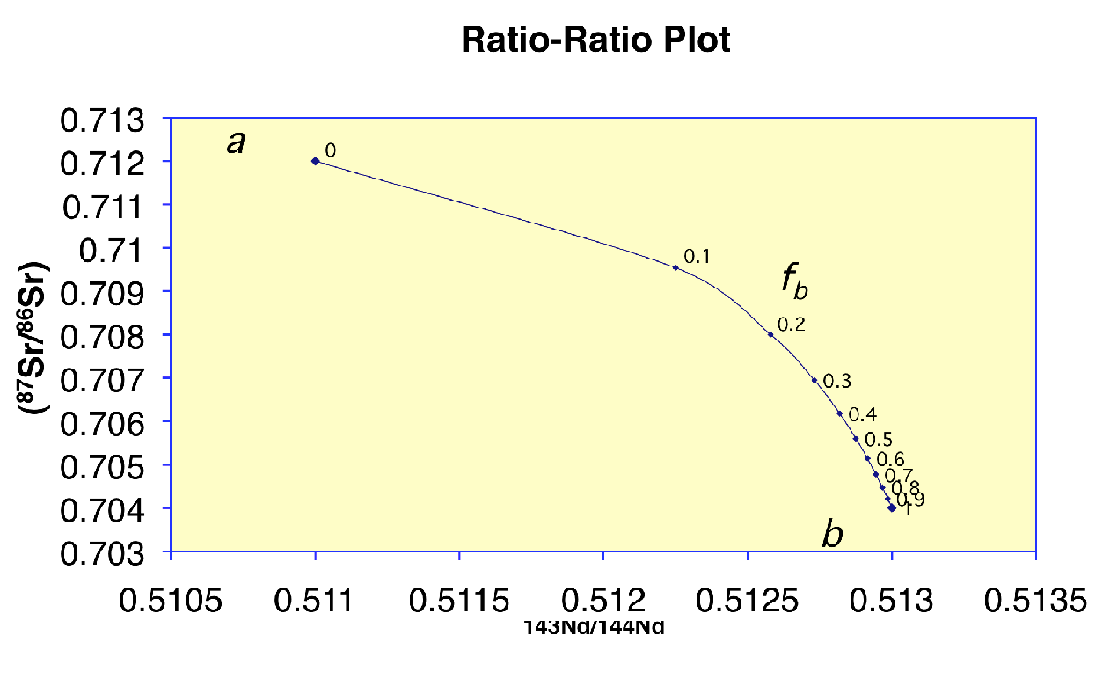

Given an array of ratio-ratio data, you can constrain the curvature parameter as well as the isotope ratios of the end members.

### Some mixing plots

**Nd vs. Sr**

14

12

10

8

6

MORB

4

2

0

Carbonate

0 200 400

600

**Sr (ppm)**

800

1000

1200



**87Sr/86Sr vs. Sr**

0.710

0.709

0.708

0.707

0.706

0.705

0.704

0.703

0.702

Carbonate

MORB

0 200 400

600

**Sr (ppm)**

800

1000

1200



**87Sr/86Sr vs. 1/Sr**

0.711

0.710

0.709

0.708

0.707

0.706

0.705

0.704

0.703

0.702

Carbonate

MORB

0 0.002 0.004

0.006

**1/Sr**

0.008

0.01

0.012

**87Sr/86Sr**

**87Sr/86Sr**

**Nd (ppm)**

**RADIOACTIVE DECAY**

**Radioactive Isotopes**

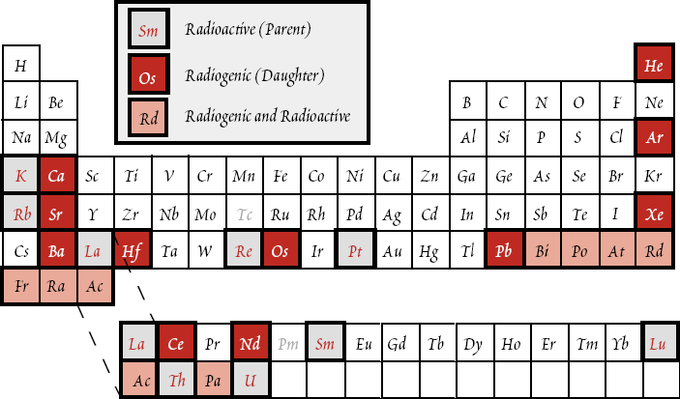

2

* **two extremely interesting and important aspects of**

**radioactive decay makes it so useful as a chronometer.**

* + Unstable nuclei decay to stable ones at **rates independent of all environmental influences**.
  + Each nucleus has a **fixed probability of decaying** per unit time. Nothing affects this probability (e.g., temperature, pressure, bonding environment, etc.)

**Radiogenic Isotopic variations is a function of:**

1. **Time (of decay since the system is closed)**
2. **Different parent/Daughters ratio**

* **Basic equation of radioactive decay: first-order rate law: Curie-Rutherford-Soddy Law:**



**Radioactive Decay**

* + **dN N or **

**dt**

**dN = N dt**

**= Activity of radionuclide**

**The minus sign simply indicates N (present-day parent concentration) decreases.**

** is the decay constant- probability of decay per unit time . Unit: time-1.**

* Integrating the decay equation, we get:

N = N0e-t

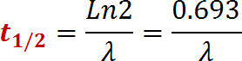Half-life:

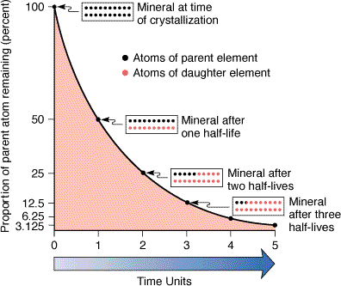The **mean life**  of a parent nuclide:

**(average life expectancy of a radioactive atom)**

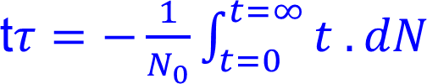

**  *N*  1

*N*

**

5

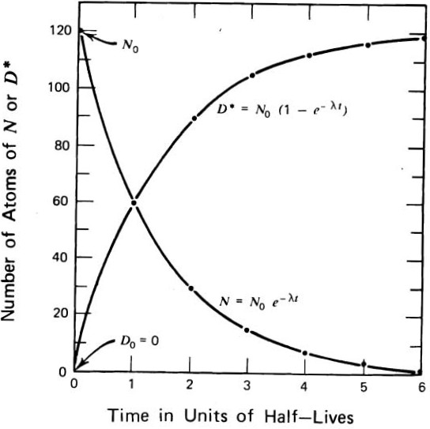

**The decay of the parent produces a daughter (D*), or radiogenic nuclide.**

**D* = No – N**

**= Net - N = N (et - 1)**

* **However, there might be some daughter isotope present in the system (initial value) to begin with.**

**Therefore: D = Do + D\***

**D = Do + N(et-1)**

**D = number of daughter atoms**

**N = number of existing parent atoms**

**Do = number of initial daughter atoms**

** = decay constant**

**D = Do + N(et-1)**

**Note that this equation is independent of N0.**

**solve the above equation for age of the system (t):**

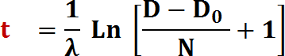

**Practical limitations on age range:**

**Very young rocks: cannot measure tiny amount of**

**daughter accurately**

**Very old rocks: cannot measure tiny amounts of**

**parent left accurately**

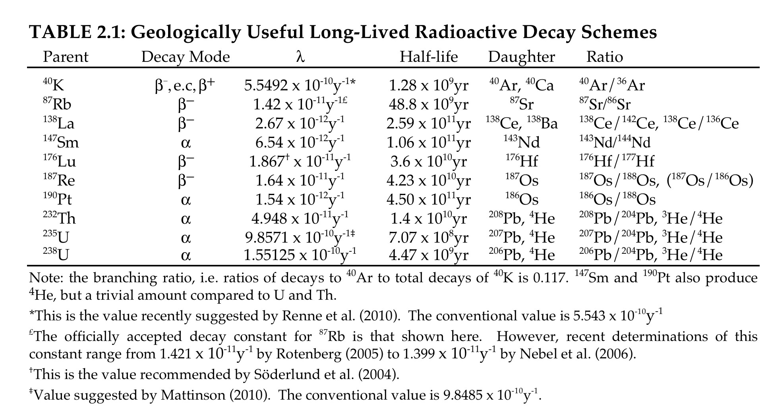

**Geologically Useful Long-Lived Radioactive Decay Schemes**

**Isochron Dating**

**87Rb37 → 87Sr38 + - +  + 0.275 Mev**

**( = 1.42 x 10-11 yr-1 ; T1/2 = 48.8 Ga )**

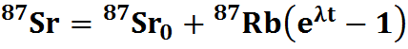

**As it turns out, it is generally much easier, and usually more meaningful, to measure ratio of two isotopes precisely than the absolute abundance of one. We, therefore, measure the ratio of 87Sr to a non-radiogenic isotope, which by convention is 86Sr. We can recast the above equation as:**

**Measured for today**

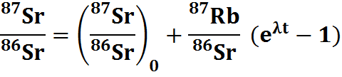

**Estimated from**

**isochrons**

**Measured for**

**today** 10



**Assumptions in age determination**

1. **System was closed between t = 0 and time t (usually the present time)**

**-no transfer of the parent or the daughter element into or out of the system**

1. **At t = 0, Concentration of parent must be different in different phases in the system, but concentration of initial daughter must be the same.**
2. **we must also know λ accurately**

**Violation of these conditions is the principal source of error in geochronology. Other errors arise from errors or uncertainties associated with the analysis.**

11

**Must satisfy: System is closed**

**Begin with 3 rocks plotting at a, b, c at time to**

**They must have same value of initial 87Sr/86Sr (87Sr/86Sr)o = value at time to**



**87Sr**

**86Sr**

**87Sr)**

**(86Sr o**

***to***

***a b c***

**87Rb**

**86Sr** 12

After some time increment (t0 t1) each sample loses some 87Rb and gains an equivalent amount of 87Sr (proportional to the amount of Rb present in the system)

87Sr



*t*

86Sr *1*

*c*

*1*

*b1*

*a1*

(87Sr )

86Sr o

*to*

*a b c*

87Rb

86Sr 13

At time t2 each rock system has evolved 

**new line. Again still linear and steeper line**

*t2*



87Sr

86Sr

(87Sr )

*c2*

t

**Isochrons**

*1*

*b2 c1*

*a2 b1*

*a1*

t

86Sr o

*a b c*

*o*

**87Rb**

**86Sr**

**All points on a single isochron line have same age.**



14

**Isochron technique produces 2 valuable things:**

1. **The age of the rocks (from the slope)**
2. **(87Sr/86Sr)o = the initial value of 87Sr/86Sr, which we did not know beforehand**

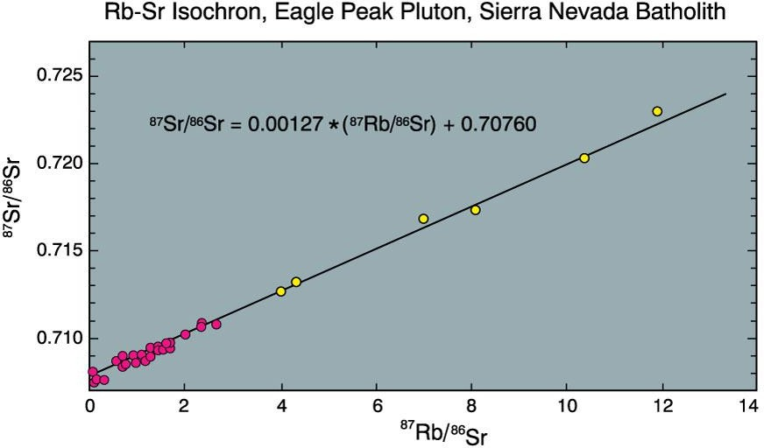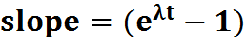

Rb-Sr isochron for the Eagle Peak Pluton, central Sierra Nevada Batholith, California, USA. Filled circles are whole-rock

analyses, open circles are hornblende separates. The regression equation for the data is also given. After Hill et al. (1988). 15

Amer. J. Sci., 288-A, 213-241.







Indian Institute of Technology, Kanpur

Department of Earth Sciences

ESO213A: Fundamentals of Earth Sciences

Lecture 29. Layered Earth

**Santanu Misra**

Department of Earth Sciences

Indian Institute of Technology, Kanpur

[*smisra@iitk.ac.in*](mailto:smisra@iitk.ac.in)[*http://home.iitk.ac.in/~smisra/*](http://home.iitk.ac.in/~smisra/)



**Aims of this lecture**

Earth’s interior

Different layers and their properties

**Reading:**

* Marshak’s Book (Chapter 2)
* Grotinger & Jordan’s book (Chapter 14) [*for the entire week*]





**Surface of the Earth**

* Our experience with Earth is limited to its surface.
* Dramatic elevation changes—mountains, canyons—are tiny “scratches” on this surface.
* Our Earth is much more vast and complex than the surface suggests.



**The Layered Earth**

* How do we know that the Earth has a layered interior?
* Early speculations sought to explain:
  + The source of lava.
  + Gem and mineral enrichment.
  + Earthquakes.
* Early guesses were wrong.
  + Open caverns to the interior
  + Flowing lava, air, water

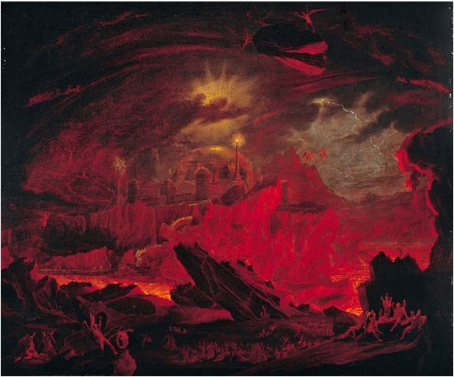

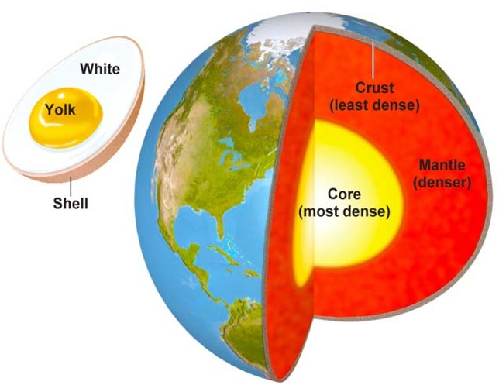

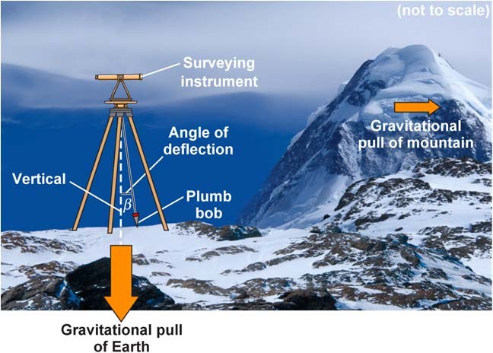

**The Layered Earth**

* The first key to understanding Earth’s interior: density.
  + A plumb bob is deflected by a nearby mountain mass.
  + Degree of deflection can be used to calculate Earth’s mass.
  + The density from this method (4.5 g/cm3) is much higher than the density of the thin outer crust (2.5 g/cm3).
  + This suggests that density must increase with depth.

Watch “**Schiehallion experiment**” here: https://vimeo.com/16031284



**The Layered Earth**

* The first key to understanding Earth’s interior: **density.**
  + In 1896, Emil Wiechert made important contributions.
    - He determined that metal must be present in Earth’s center
  + We now know he was correct.
  + His ideas led to a model:
    - Earth is like an egg.
      * Thin, light crust (eggshell)
      * Thicker, more dense mantle (eggwhite)
      * Innermost, very dense core (yolk)
  + Other density observations:
    - The land doesn’t have large tides, hence Earth’s center must be solid.



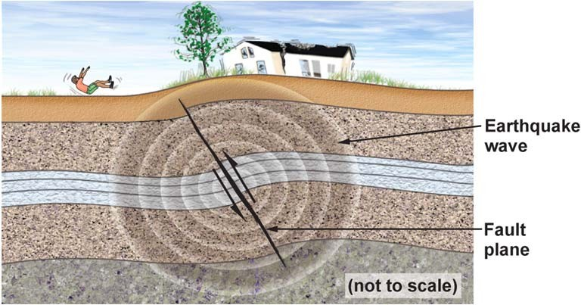

**The Layered Earth**

* Earthquakes: seismic energy from fault motion.
  + Seismic waves provide insight into Earth’s interior.
    - Seismic wave velocities change with density.
    - We can determine the depth of seismic velocity changes.
    - Hence, we can tell where densities change in Earth’s interior.



**The Layered Earth**

* Geologists strived to understand the nature of the layers.
  + Studied meteorites as analogues for core and mantle.
  + Conducted laboratory experiments.
    - Density measurements of rocks from the interior
    - Characteristics of mantle‐derived rocks and minerals
    - Determined high P and T stability field of rocks and minerals

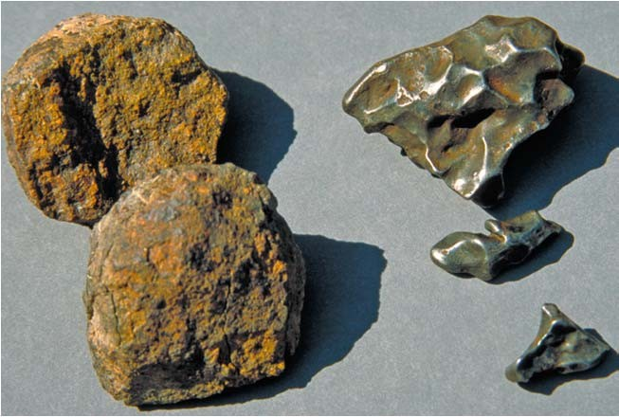

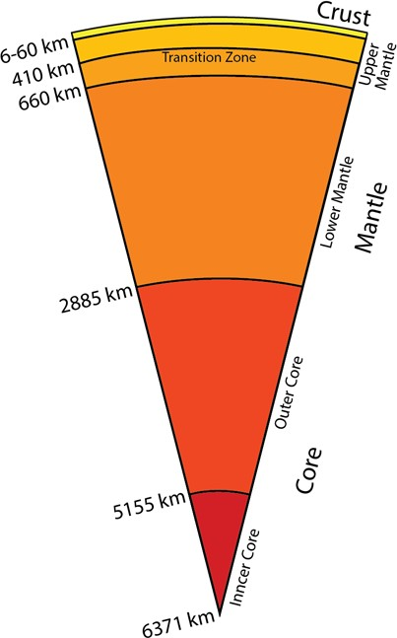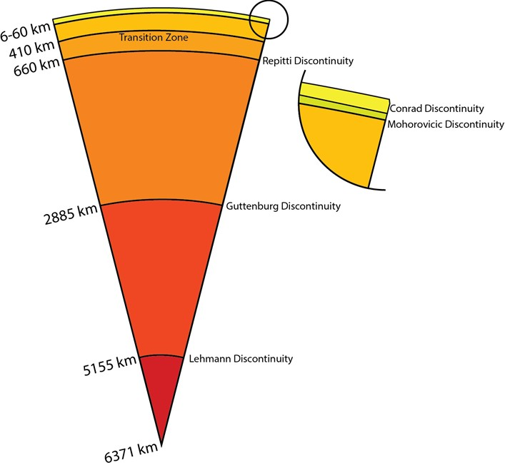



**The Layered Earth**

* End result of a century of investigation?
  + We know much about the nature of Earth’s interior.
  + This knowledge continues to evolve.
* Earth’s layers consist of the crust, upper, transitional, and lower mantles, and liquid outer and solid inner cores.
* Much complexity characterizes even within these layers.



**The Layered Earth**

* What are the boundaries?

**CONRAD discontinuity (15‐20 km, for CC only):**

between upper and lower Crust (questionable)

**MOHOROVICIC discontinuity (6‐60 km):**

between Crust and Mantle

**REPITTI discontinuity (660 km):**

between upper and lower Mantle

**GUTTENBURG discontinuity (2885 km):**

between Mantle and Core

**LEHMANN discontinuity (5155 km):**

between Outer and Inner Core

**The Layered Earth**

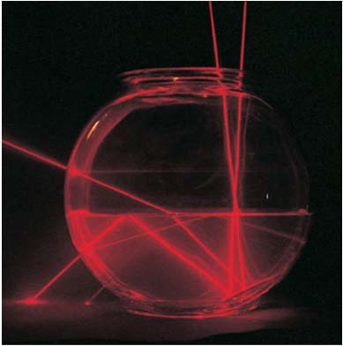

* How are the layers detected?

The velocity of waves, in general, is a function of the medium they are travelling through

The waves also reflect, and refract at the interfaces of different media

Geologists use all such wave properties, applicable to SEISMIC waves, together with a few more.

High Density → higher velocity More solid like → higher velocity

two beams of laser light enter a bowl of water from the top at slightly different angles. Both beams are reflected from a mirror on the bottom of the bowl. One is then reflected at the water‐air boundary and passes through the bowl to make a bright spot on the table. Most of the light in the other beam is bent (refracted) as it passes from the water to the air, although a small amount is reflected to form a second spot on the table





**The Seismic Waves**

**Seismic waves** (*elastic waves*) are the waves of energy caused by the sudden breaking of rock within the earth or an explosion. They are the energy that travels through the earth and is recorded on seismographs.

The first waves to arrive are called primary waves, or **P waves.** The secondary waves, or **S waves,** follow. Both P waves and S waves travel through Earth’s interior and known as **BODY WAVES**. Afterwards come the slower **SURFACE WAVES,** which travel around Earth’s surface.

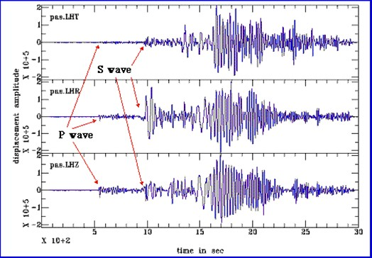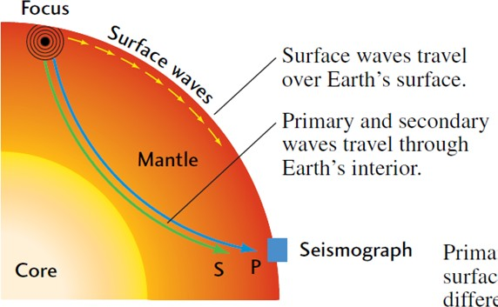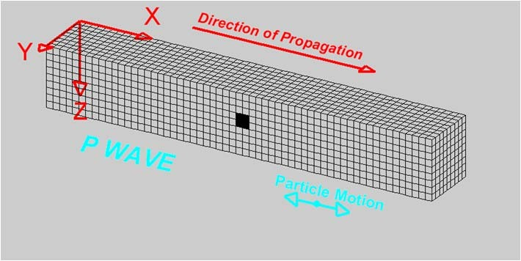

**The Seismic Waves**

**P waves** in rock are similar to sound waves in

air, except that P waves travel through the solid rock of Earth’s crust at about 6 km/s, which is about 20 times faster than sound waves travel through air. Like sound waves, P waves are *compressional waves,* because they travel through solid, liquid, or gaseous materials as a succession of compressions and expansions.

P waves are harmless in terms of earthquake damage.

http[s://www](http://www.zmescience.com/).z[mescien](http://www.zmescience.com/)c[e.c](http://www.zmescience.com/)o[m](http://www.zmescience.com/)

𝑉P=

K+ 4 µ

3

q

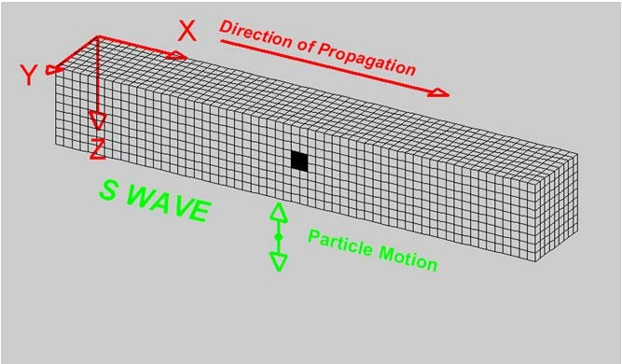

**The Seismic Waves**

**S waves (shear waves)** travel through solid

rock at a little more than half the velocity of P waves. They are *shear waves* that displace material at right angles to their path of travel.

Shear waves cannot travel through liquids or gases and also rarely do any significant damage

𝑉S=

µ

q

http[s://www](http://www.zmescience.com/).z[mescien](http://www.zmescience.com/)c[e.c](http://www.zmescience.com/)o[m](http://www.zmescience.com/)

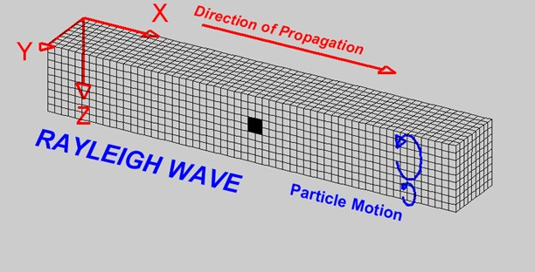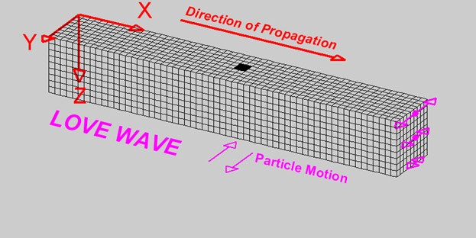

**The Seismic Waves**

Surface waves **(Love waves)** have a transversal

(perpendicular) movement and are the most destructive outside the immediate area of the epicentre. Love waves can be devastating.

**Surface waves (Rayleigh waves)** do by far the

most damage. As opposed to S and P, they propagate on the surface and carry the vast majority of the energy felt on the surface.

https://[www.zmescience.com](http://www.zmescience.com/)

https://[www.zmescience.com](http://www.zmescience.com/)



**The Seismic Waves**

Surface waves **(Love waves)** have a transversal

(perpendicular) movement and are the most destructive outside the immediate area of the epicentre. Love waves can be devastating.

**Surface waves (Rayleigh waves)** do by far the

most damage. As opposed to S and P, they propagate on the surface and carry the vast majority of the energy felt on the surface.

https://[www.zmescience.com](http://www.zmescience.com/)

https://[www.zmescience.com](http://www.zmescience.com/)



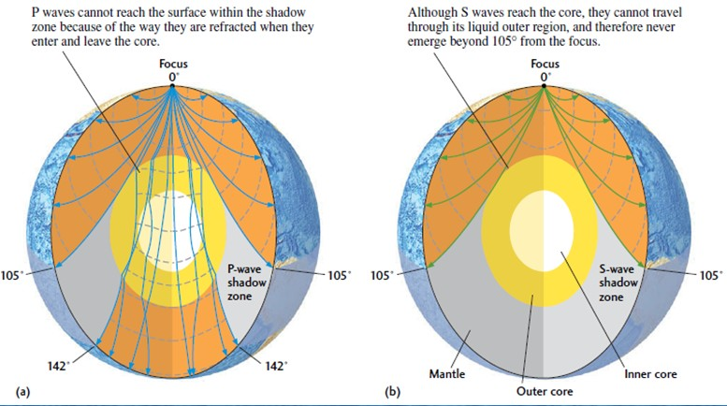

**Seismic Waves through Earth’s interior**

Observations of travel times and the amount of upward refraction of the ray paths, suggest that P waves travel much faster through deep Earth than at Earth’s surface → THIS IS OKAY.

Interestingly, the P and S waves disappear beyond about 11,600 km (105°) from the source [each degree measures 111 km at the surface). Beyond about 15,800 km from the focus (142°), the P waves suddenly reappeared, although they were much delayed compared with their expected travel times. The S waves never reappeared.→ WOW



**Seismic Waves through Earth’s interior**

**P waves missing from 105‐142°:** At 105°, ray paths of P waves encounter the core‐mantle boundary. At that boundary, P‐wave velocity drops by almost a factor of two because of density contrast. The waves are refracted downward into the core and emerge at greater angular distances after the delay caused by their detour through the core.

**S waves missing after 105°:** Earth a liquid outer core (R. D. Oldham, 1906). S waves cannot travel through the outer core, because it is liquid, and liquids have no resistance to shearing. Thus, there is an S‐wave **shadow zone** beyond 105 from the earthquake focus, where S‐wave ray paths encounter the core‐mantle boundary.

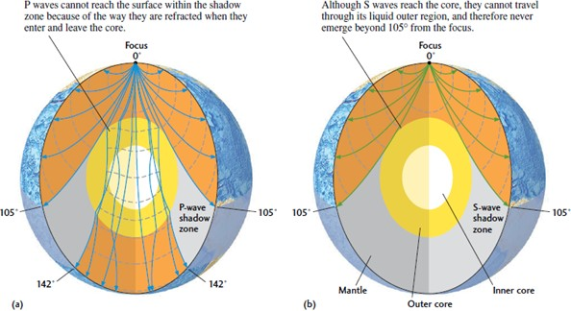

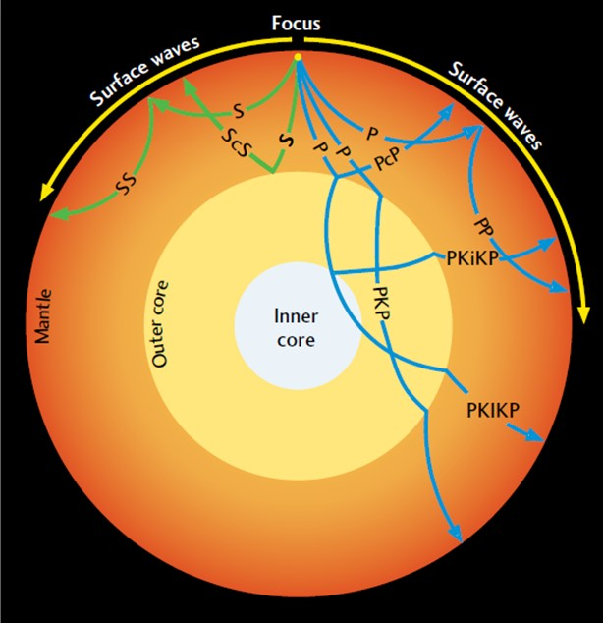

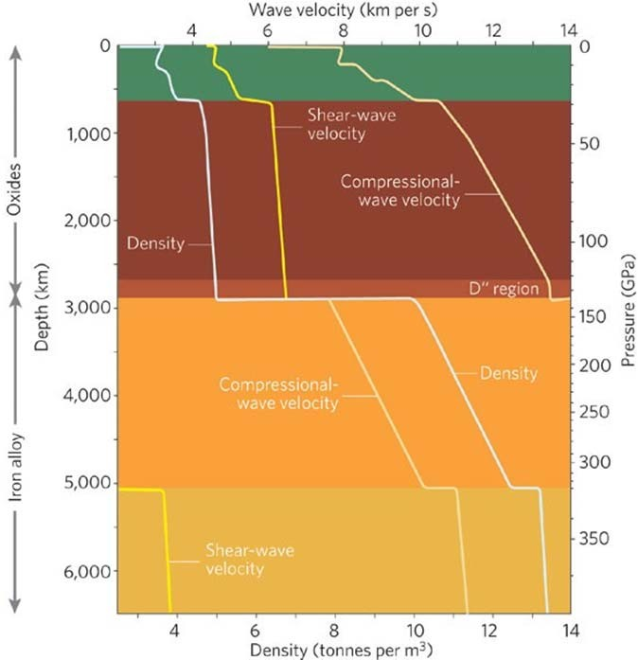

**Seismic Waves through Earth’s interior**

The first‐order structural units of Earth

— its suite of concentric shells and their approximate composition — were established over the first half of the twentieth century from measurements of the travel times of seismic waves refracted and reflected inside Earth, whereas proof of the solidity of the inner core had to await the capability to record and digitize long time series and measure the frequencies of free oscillations. The '660 km' discontinuity is a phase change, and possibly a compositional change, in the silicate mantle. This illustration is of the Preliminary Reference Earth Model (PREM)

Romanowicz, Nature, 2008

Dziewonski and Anderson, PEPI, 1981



**Seismic Waves through Earth’s interior**

Geologists use a simple labelling scheme to describe the various ray paths taken by seismic waves.

PcP and ScS are compressional and shear waves, respectively, that are reflected by the core.

PP and SS waves are internally reflected from Earth’s surface.

A PKP wave travels through the liquid outer core, a PKIKP wave travels through the solid inner core, and a PKiKP wave is reflected by the inner core.

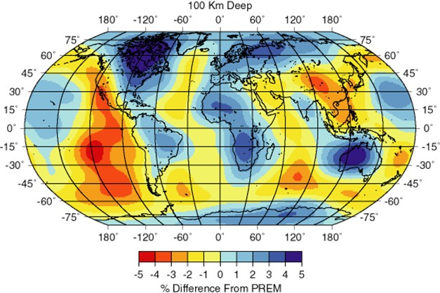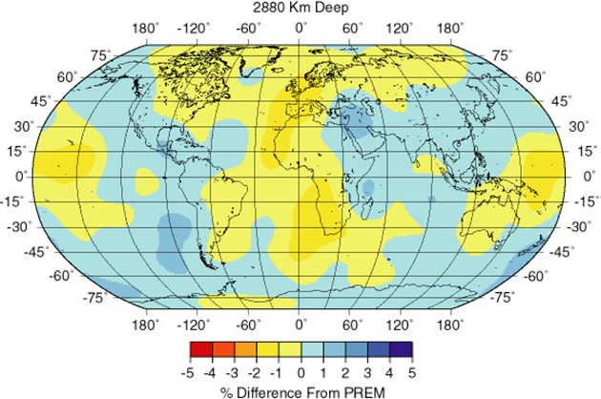



**Seismic Waves through Earth’s interior**

Su et al, JGR Solid Earth, 1994

In shallow (~100 km) regions where material is rising from the mantle, it should be warmer, and the velocity should be lower, in regions that are old and cold, such as beneath many of the old parts of continents, we would expect to see faster regions (assuming that temperature is the only difference). The actual variations are influenced by both temperature and composition variations, but they agree well with the ideas of plate tectonics, particularly at the divergent boundaries or oceanic spreading ridges.



**Seismic Waves through Earth’s interior**

Su et al, JGR Solid Earth, 1994

Shear wave variations at 2,880 km depth , just above the core‐mantle boundary. See the lower‐mantle velocity variations are more subdued than those in the more heterogeneous upper mantle. Also, note that the correlation with surface tectonics is gone, as you would expect for a complex convective system such as Earth's mantle.

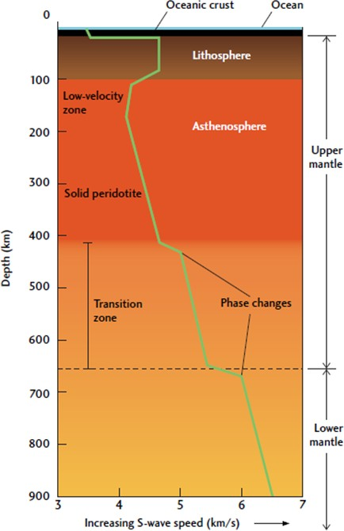



**The Layered Earth**

* What are the Compositions?

**CRUST**

* + Felsic rocks typical of the upper continental crust (granite): VP 6 km/s; 2.6 g/cc
  + Mafic rocks typical of oceanic crust or the lower

continental crust (gabbro): VP 7 km/s; 2.9 g/cc

* + Ultramafic rocks typical of the upper mantle (peridotite): VP 8 km/s; 3.3 gm/cc

**Mantle**

* + From MOHO to 410 km (peridotire: iron‐ and magnesium‐ rich silicate minerals)
  + From 410‐660 km (high pressure variations of olivine – the MTZ (Wadsleyite & Ringwoodite)
  + From 660‐2885 km (Lower Mantle – Perovskite)



**The Layered Earth**

* What are the Compositions?

**CORE‐MANTLE BOUNDARY (CMB)**

* + Dramatic change in composition; from high pressure solid silicate to liquid Fe‐alloy
  + The last 200 km at the base of lower mantle (known as D” layer) receive extreme heat and responsible for driving the Mantle Convection.
  + Plumes also originate from the CMB.
  + This zone is also the graveyard of the subduccted lithosphere.

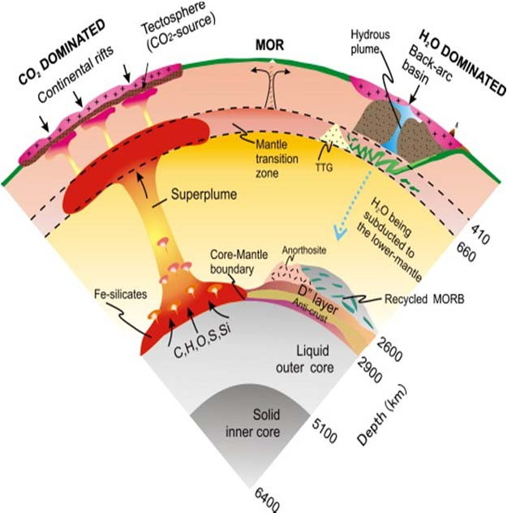





**The Layered Earth**

* What are the Compositions?

**CORE**

* + Outer core Liquid and Inner Core Solid.
  + Composition is Fe‐Ni alloy
  + We have very limited information about the core



**Next Lecture**

Temperature and other related properties







Indian Institute of Technology, Kanpur

Department of Earth Sciences

ESO213A: Fundamentals of Earth Sciences

Lecture 30. Mantle Dynamics

**Santanu Misra**

Department of Earth Sciences

Indian Institute of Technology, Kanpur

[*smisra@iitk.ac.in*](mailto:smisra@iitk.ac.in)[*http://home.iitk.ac.in/~smisra/*](http://home.iitk.ac.in/~smisra/)



**Aims of this lecture**

Earth’s Temperature profile Heat transfer in Earth’s Mantle Mantle Convection

**Geodynamics:** *Turcotte and Schubert, Chambridge University Press (3rd Ed)*

**Reading:**

* Marshak’s Book (Chapter 2)
* Grotinger & Jordan’s book (Chapter 14)

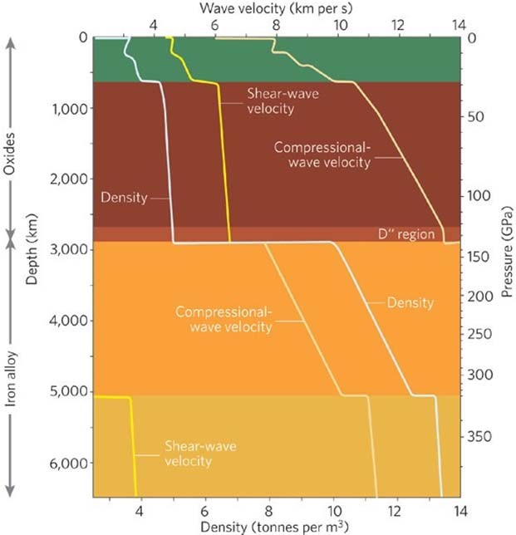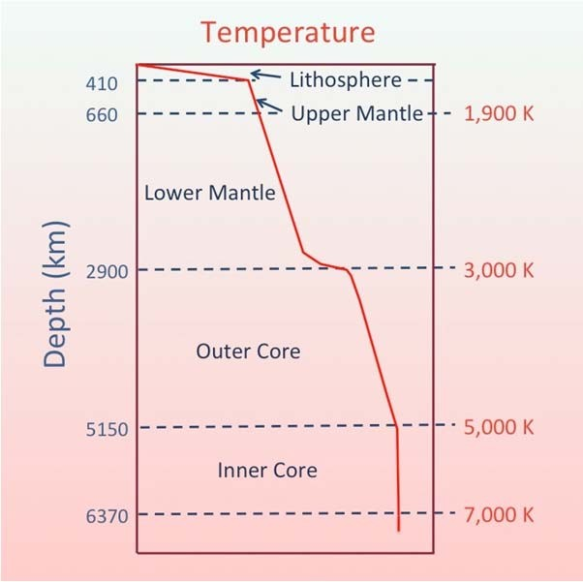

As a whole

Crust and upper Mantle

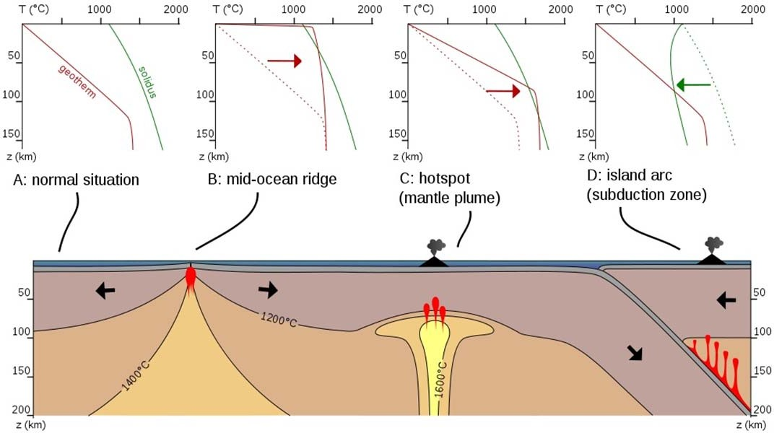

The Earth is cooling... losing internal energy.

Heat is being released from the Earth's interior at a rate of about *44TW/year*. Averaged over the surface of the Earth, this amounts to a heat flow of about *70W/m2* through the crust .

Heat energy diffuses through the crust and lithosphere by conduction according to Fourier's Law of Thermal Conduction.

With magmas at volcanoes and spreading ridges, heat is being advected to the surface. Actually, this accounts for only a fraction of the heat that is brought to the surface and radiated through the atmosphere into space.

Heat conduction through the lithosphere

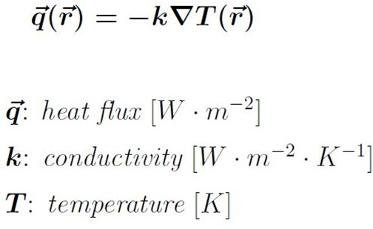

Heat transfer is in the direction of decreasing temperature

(basis for minus sign).

Direction of heat transfer is perpendicular to lines of constant temperature (isotherms).

Heat flux vector may be resolved into orthogonal components.

Fourier’s Law serves to define the thermal conductivity of the medium

A rate equation that allows determination of the conduction heat flux from knowledge of the

temperature distribution in a medium

Fourier’s Law of heat conduction

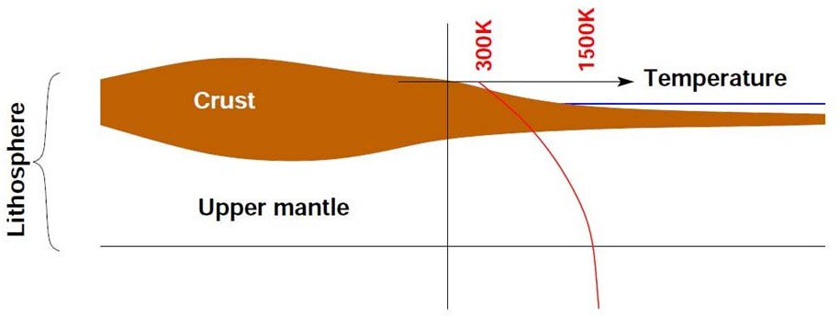





For a lithosphere with *100km* depth (i.e., an average gradient of *12K/km*), the average lithospheric thermal conductivity: *k ~ 4 W m‐2 K‐*1 .

Measured conductivities of surface rocks: *k ~ 2‐3 W m‐2 K‐1* .

Temperature through the lithosphere and crust

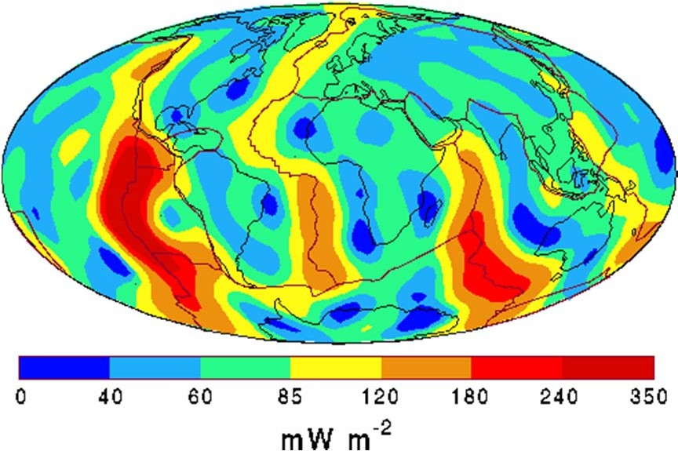

[http://geophysics.ou.edu](http://geophysics.ou.edu/)

Global Distribution of Heat Flow

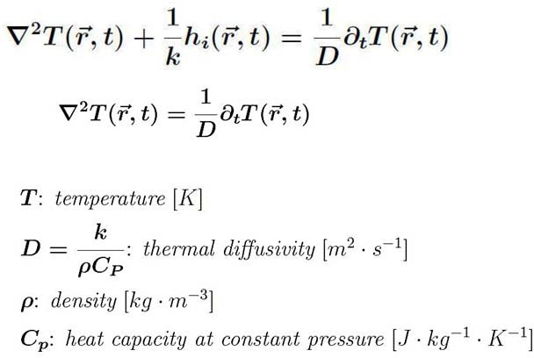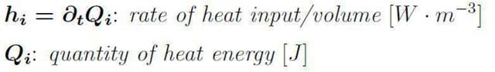

Thermal diffusion (conductive)



Heat flows out of the depths of the cooling Earth transported through the mantle between the D'' layer

and the base of the lithosphere by convective fluid motions rather than conduction. This is the more effective means of moving heat through a fluid.

*How does convection work?*

It’s not conduction! More rapid heat transfer. Raise a parcel of hot rock.

If constant entropy: Lower P => expands => larger volume => decreasing T

This is known as adiabatic process.

The mantle behaves like a *viscous fluid* on long timescales; being a fluid, it can flow and can be driven

into convection by a temperature gradient.

The contribution of diffusive cooling of the mantle is insignificant in comparison to convective heat

transport through the mantle.

Thermally driven mantle convection

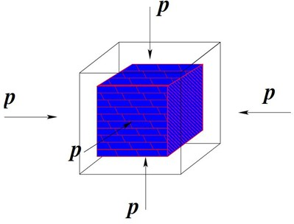

𝐶p 𝜌

∆𝑇 = 𝛼𝑃 𝑇𝑔⃗𝜌∆𝑟

*T*: Temperature

*P*: Pressure

**: Density

**: Thermal expansion

*Cp*: Heat capacity

𝐶p

∝ 𝛼𝑃

𝜌

∝ 1

∆𝑇 ∝ ∆𝑃

∝ 𝑇

Consider a cube of mantle material under pressure

Energy is received due to work…

Adiabatic compression



…. is this sufficient?

𝛼𝑇

= 𝜌 𝐶p

S

Adiabatic *T* gradient as a function of *P*

𝜕𝑇

𝜕𝑃

Re‐arranging

P

𝜕𝑆

𝑚𝐶p = 𝑇 𝜕𝑇

Specific heat

𝑉 𝜕𝑇 P

𝛼 = 1

Coefficient of thermal expansion

P

𝜕𝑉

= — 𝜕𝑇

𝜕𝑉

T

𝜕𝑆

𝜕𝑃

Maxwell’s thermodynamic relation

𝜕𝑆

𝜕𝑃 T

𝜕𝑆 P

= — 𝜕𝑇

𝜕𝑇

𝜕𝑃 S

Need the change of temperature with pressure at constant entropy, ***S***

Adiabatic temperature gradient





𝛼 𝑇 𝑔

𝐶p

S

𝜕𝑇

𝜕𝑟 =

Re‐arranging

𝑑𝑟 = —𝑔𝜌

𝑑𝑃

For the Earth

best to have it as function of depth…

= 𝛼𝑇

𝜕𝑃 S 𝜌 𝐶p

𝜕𝑇

Adiabatic temperature gradient

Mantle temperature?

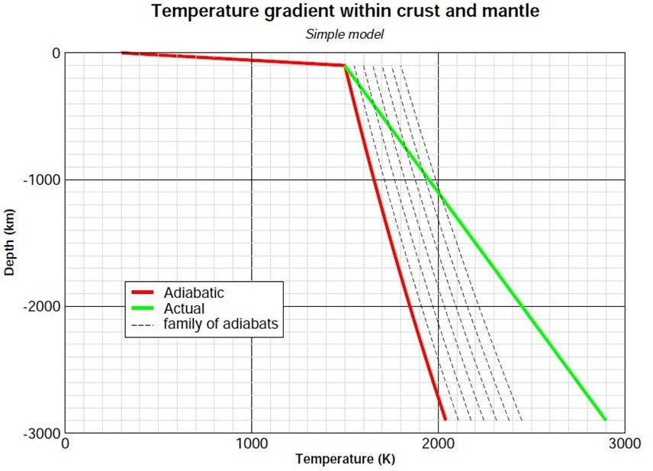

If the actual temperature gradient (i.e., the increase of temperature with depth) exceeds the local adiabatic temperature gradient, then any infinitesmal displacement of a volume of mantle material will be enhanced through buoyancy, if displaced upwards or negative bouyancy if displaced downwards.

**We have “*convection*”!**

The process of convection removes heat from depth in the mantle to the base of the lithosphere where it is conducted out to the surface. The interior cools; the actual temperature gradient reduces.

The process of convection pulls the entire mantle temperature toward the adiabatic gradient. If the temperature gradient falls to the adiabatic or below, convection ceases!

If the temperature at the base of the lithosphere is *1500 K* as corresponds to Hawaiian lava eruptions, then the adiabatic gradient to top of the D'' layer would account for a base temperature in excess of about *2100 K* depending on the distributed thermal expansivity, *αp* , and heat capacity, *Cp*, throughout the mantle.

Heat “conducts” into the fluid mantle through the D'' boundary layer.

If the actual temperature gradient exceeds the adiabatic gradient?



**In a fluid:**

Occurs when density distribution deviates from equilibrium Fluid may then flow to achieve equilibrium again

**In a viscous solid heated from below:**

Initially heat is transported by conduction into the fluid at the base

Increased temperature reduces the density making the material at the base less dense than fluid above Once the buoyancy force due to the density contrast overcomes the inertia of the fluid convection begins

Mantle convection

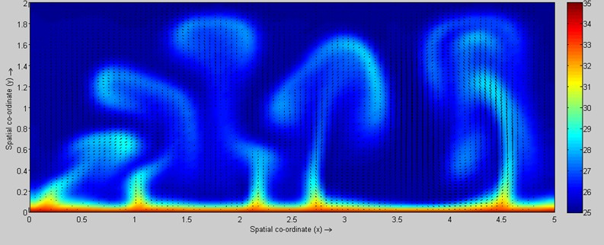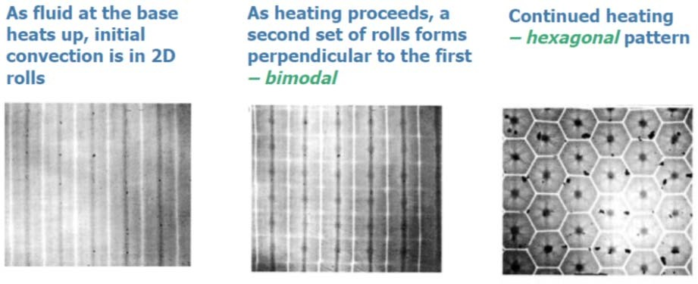

**Read:**

David White (1988); *The planforms and onset of convection with a temperature‐dependent viscosity*; Journal of Fluid Mechanics, 191, 247‐286.

Spoke to irregular pattern

**Newtonian viscous fluid:**

Stress = dynamic viscosity x strain rate

Rayleigh‐Bernard convection

Rayleigh‐Bernard convection ‐ examples



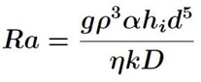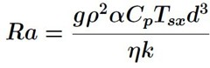



Rayleigh number

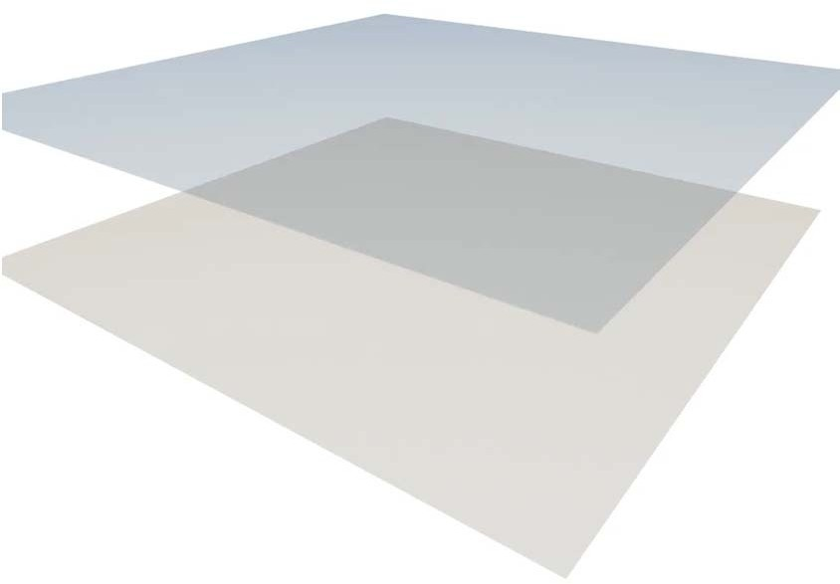

Rayleigh‐Bernard convection ‐ examples

Convection can be *driven* by internal or bottom heating. Surely, both contribute.

The Rayleigh number measures the ratio of the forcing‐to‐retardation of the convection. A nondimensional number which describes the nature of heat transfer by suggesting the relationships between buoyancy and viscosity with a fluid

For internal heating:

*η* is the local viscosity,

*Tsx*, the local adiabatic excess.

*D* is mantle thickness, base of lithosphere to D''.

For bottom heating:

**The critical Rayleigh number:**

The point at which convection initiates Approximately > 103 (dependent on geometry)

By knowing the material properties and physical geometry we can determine if there will be convection and the nature of that convection

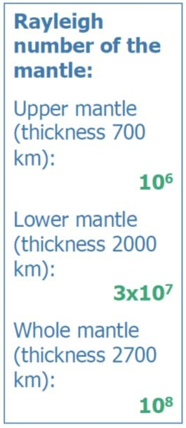

NO

CONVECTION

**103**

CYLINDRICAL

CELLS

**104**

BIOMODAL

FLOW

**105**

SPOKE

PATTERN

**106**

MANTLE

CONVECTION

**107**

Rayleigh number and convective mode

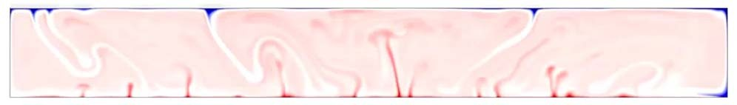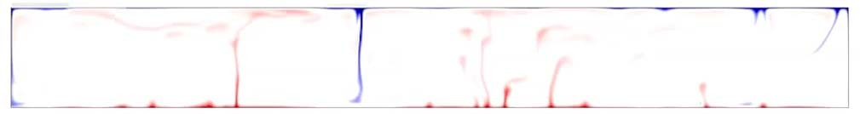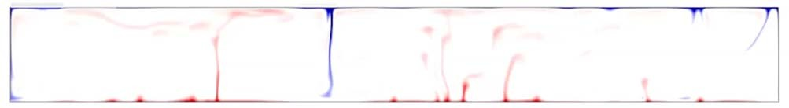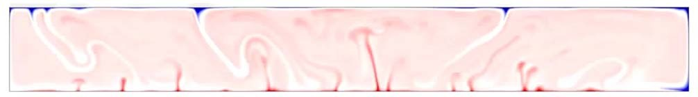

* Temperature dependence of Viscosity: ‐‐‐ x contrast between hottest and coldest

107

0 x

0

0

Ra

T of viscosity*

η increase @ 660 Internal heating

107

10 x

0

0

Ra

T of viscosity*

η increase @ 660 Internal heating

107

100 x

0

0

Ra

T of viscosity*

η increase @ 660 Internal heating

107

1000 x

0

0

Ra

T of viscosity*

η increase @ 660 Internal heating

Mantle convection – temperature dependence of Viscosity

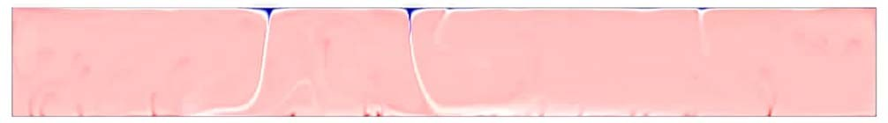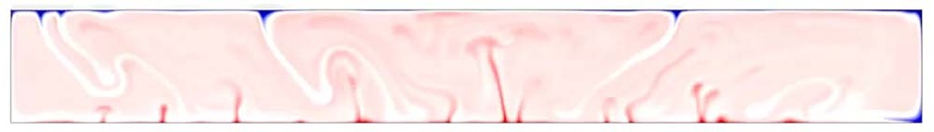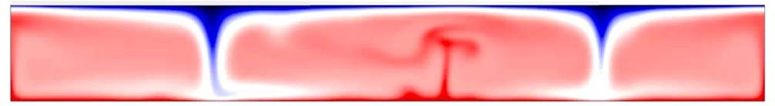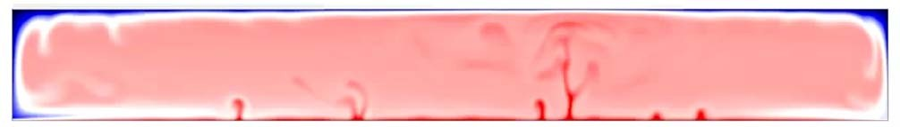

* Temperature dependence of Viscosity: ‐‐‐ x contrast between hottest and coldest

105

1000 x

0

0

Ra

T of viscosity

η increase @ 660 Internal heating

106

1000 x

0

0

Ra

T of viscosity

η increase @ 660 Internal heating

Mantle convection – Rayleigh number variation

|  |  |
| --- | --- |
| Ra  T of viscosity  η increase @ 660 | 108  1000 x  0 |
| Internal heating | 0 |
| Ra | 107 |
| T of viscosity | 1000 x |
| η increase @ 660 | 0 |
| Internal heating | 0 |



* Temperature dependence of Viscosity: ‐‐‐ x contrast between hottest and coldest

107

1000 x

0

40

Ra

T of viscosity

η increase @ 660 Internal heating

107

1000 x

0

20

Ra

T of viscosity

η increase @ 660 Internal heating

107

1000 x

0

0

Ra

T of viscosity

η increase @ 660 Internal heating

Mantle convection – variation due to internal heating





Isotopic ratios of oceanic basalts are

very uniform but different from bulk earth values

**The mantle is well mixed**

Mantle convection – the effect of heating ‐ summary

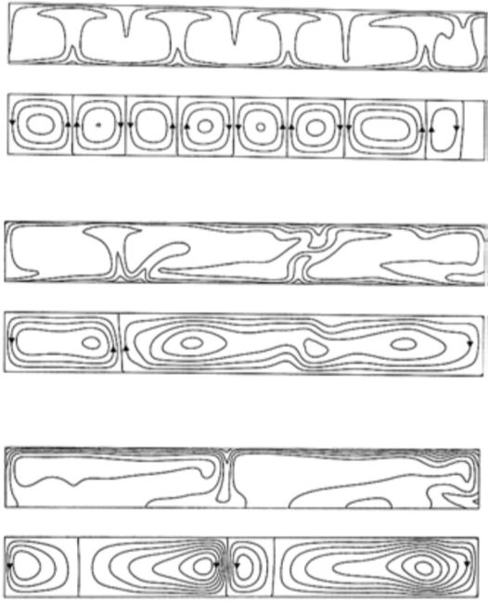

Internal heating only

**No upwelling sheets**

Heat from below

Constant heat flow across upper boundary

**Large aspect ratio**

… realistic?

Heat from below

T is fixed on upper boundary

**Aspect ratio of 1**

… not what we see on Earth

Mantle convection – the effect of heating ‐ summary

**Any body smaller than 1000 km is**

**reduced to less than 1 cm thick in 825 Ma !**

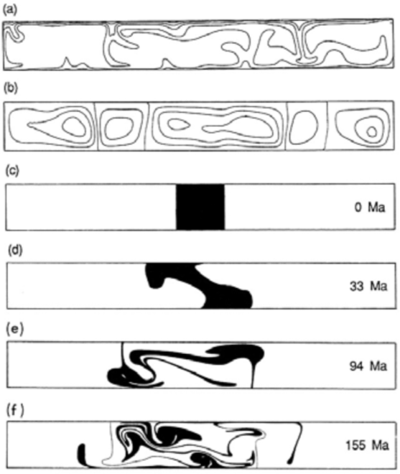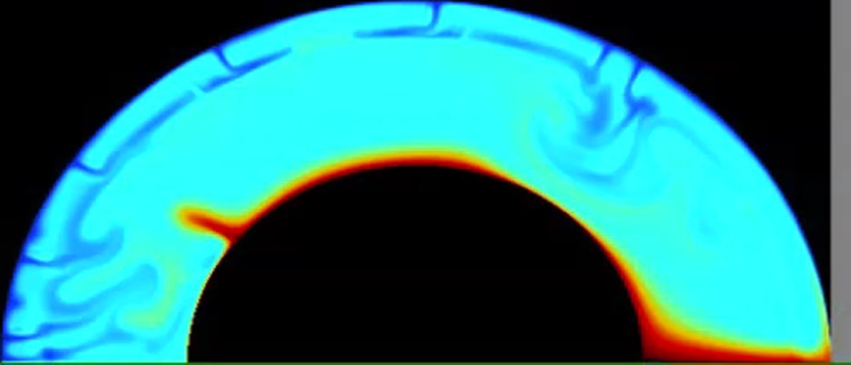

core

mantle

Mantle convection – A near perfect combination



There is/was a long‐standing debate concerning the possibly layered convection in the mantle.

There is general agreement that the 660 km phase change does retard sinking subducting plates and bouyant rising melts during convection

There is also general agreement that plates can and do penetrate through 660 and that rising plumes and convective sheets rise through 660.

Seismic tomography shows that we have a pooling of material around 660 as would be expected of layered convection while there remains sufficient penetration to involve the whole mantle in the convective process.

Layered mantle convection?

crust

Source: Paul Tackley, ETH Zurich

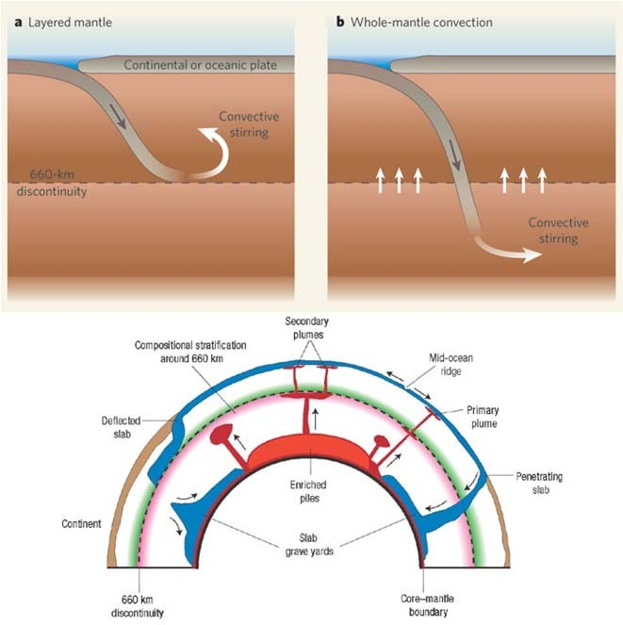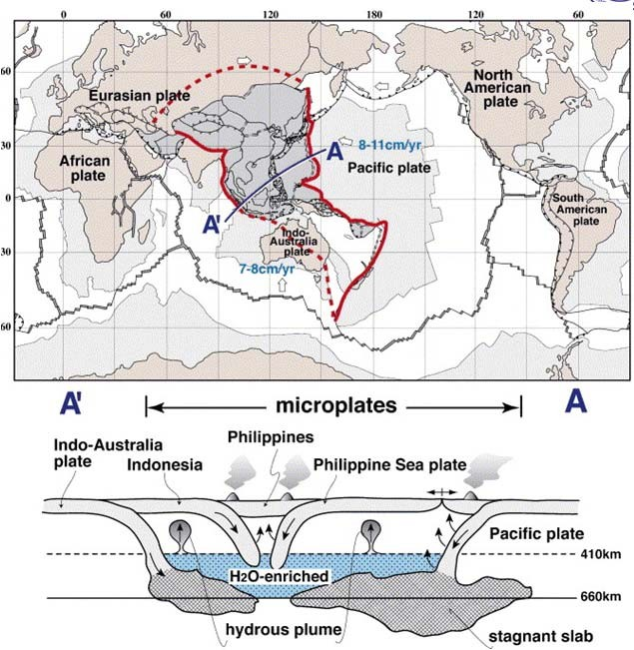

In East Asia, the old Pacific plate subducts from the east, and the Indo‐Australia plate from the south (double‐sided subduction zone).

The upper and lower mantle here are the coldest mantle regions in the world.

This is the most active region on the Earth, indicating that the role of water is several orders of magnitude higher than that of the temperature in terms of lowering viscosity and drop of solidus. Note also the predominant occurrence of microplate in this region. Not only the fragmentation of continents but also the formation of small oceans constitutes the major reason for the dominant occurrence of microplates.

The schematic cross‐section of WPTZ is shown below to illustrate the stagnant slabs, hydrous MBL, and formation of hydrous plumes at 410 km depth by the breakdown reaction of hydrous wadsleyite enriched in incompatible elements

Stratified mantle



Earth has mantle convection and plate tectonics – Why? When did it start? How long it will continue?

What about other planets?

Some questions…